Multimodal Emotion Recognition with Adaptive Fusion and Reliability-Aware Attention using Lightweight Transformer Architectures
A project report submitted in partial fulfilment of the requirement for the Award of the Honors Degree of
BACHELOR OF ENGINEERING
in
Computer Science & Engineering
by
SAINATH CHAKRAVADHANULA (160722733010)
Under the Guidance of
Mr. MUJTABA GULAM MUQEETH,
Associate Professor, Dept. of CSE


Department of Computer Science and Engineering
Methodist College of Engineering and Technology (Autonomous), King Koti, Abids, Hyderabad-500001.
2025-2026

Methodist College of Engineering and Technology,
King Koti, Abids, Hyderabad-500001,

Department of Computer Science and Engineering



DECLARATION BY THE CANDIDATES

I, Sainath Chakravadhanula (160722733010), student of Methodist College of Engineering and Technology, pursuing Honors degree in Computer Science & Engineering, hereby declare that this Project report entitled “Multimodal Emotion Recognition with Adaptive Fusion and Reliability-Aware Attention using Lightweight Transformer Architectures", carried out under the guidance of Mr. Mujtaba Gulam Muqeeth submitted in partial fulfilment of the requirements for the Honors Degree in Computer Science & Engineering, during the academic year 2025-2026. This is a record of work carried out by me and the results embodied in this report have not been reproduced/copied from any source.

SAINATH CHAKRAVADHANULA (160722733010)

Methodist College of Engineering and Technology,
King Koti, Abids, Hyderabad-500001.

Department of Computer Science and Engineering


CERTIFICATE BY THE SUPERVISOR

This is to certify that this Project Report on the work entitled “Multimodal Emotion Recognition with Adaptive Fusion and Reliability-Aware Attention using Lightweight Transformer Architectures” by SAINATH CHAKRAVADHANULA (160722733010), submitted in partial fulfilment of the requirements for the Honors Degree in Computer Science & Engineering, during the academic year 2025-2026, is a bonafide record of work carried out by them.

Mr. MUJTABA GULAM MUQEETH,
Date: Associate Professor,
Dept. of CSE
Methodist College of Engineering and Technology,
King Koti, Abids, Hyderabad-500001.

Department of Computer Science and Engineering


CERTIFICATE BY HEAD OF THE DEPARTMENT

This is to certify that this Project Report on the work entitled “Multimodal Emotion Recognition with Adaptive Fusion and Reliability-Aware Attention Using Lightweight Transformer Architectures” by SAINATH CHAKRAVADHANULA (160722733010), submitted in partial fulfilment of the requirements for the Honors Degree in Computer Science & Engineering, during the academic year 2025-2026, is a bonafide record of work carried out by them.

Dr. P. LAVANYA,
Professor & Head of the Department, Computer Science & Engineering
Date:

Methodist College of Engineering and Technology,
King Koti, Abids, Hyderabad-500001.

Department of Computer Science & Engineering


PROJECT APPROVAL CERTIFICATE

This is to certify that this Project Report on the work entitled “Multimodal Emotion Recognition with Adaptive Fusion and Reliability-Aware Attention using Lightweight Transformer Architectures” by SAINATH CHAKRAVADHANULA (160722733010), submitted in partial fulfilment of the requirements for the Honors Degree in Computer Science & Engineering, during the academic year 2025-2026, is a bonafide record of work carried out by them

INTERNAL EXTERNAL HOD

ACKNOWLEDGEMENT

We would like to express our sincere gratitude to my project guide Mr. Mujtaba Gulam Muqeeth, Associate Professor, CSE, for giving us the opportunity to work on this topic. It would never be possible for us to take this project to this level without his innovative ideas and his relentless support and encouragement.
We would like to thank our project coordinator Mr. Mujtaba Gulam Muqeeth, Associate Professor, CSE, who helped us by being an example of high vision and pushing towards greater limits of achievement.
Our sincere thanks to Dr. P. Lavanya, Professor and Head of the Department of Computer Science and Engineering, for her valuable guidance and encouragement which has played a major role in the completion of the project and for helping us by being an example of high vision and pushing towards greater limits of achievement.
We would like to express a deep sense of gratitude towards the Dr. Prabhu G. Benakop, Principal, Methodist College of Engineering and Technology, for always being an inspiration and for always encouraging us in every possible way.
We would like to express a deep sense of gratitude towards the Dr. Lakshmipathi Rao, Director, Methodist College of Engineering and Technology, for always being an inspiration and for always encouraging us in every possible way.

We are indebted to the Department of Computer Science & Engineering and Methodist College of Engineering and Technology for providing us with all the required facility to carry our work in a congenial environment. We extend our gratitude to the CSE Department staff for providing us to the needful time to time whenever requested.
We would like to thank our parents for allowing us to realize our potential, all the support they have provided us over the years was the greatest gift anyone has ever given us and also for teaching us the value of hard work and education. Our parents have offered us with tremendous support and encouragement, thanks to our parents for all the moral support and the amazing opportunities they have given us over the years.



Vision & Mission

VISION
To become a leader in providing Computer Science & Engineering education with emphasis on knowledge and innovation.

MISSION
M1: To offer flexible programs of study with collaborations to suit industry needs
M2: To provide quality education and training through novel pedagogical practices
M3: To Expedite high performance of excellence in teaching, research and innovations.
M4: To impart moral, ethical valued education with social responsibility.

Program Educational Objectives
Graduates of Compute Science and Engineering at Methodist College of Engineering and Technology will be able to:
PEO1: | Apply technical concepts, Analyse, synthesize data to Design and create novel products and solutions for the real-life problems.
PEO2: | Apply the knowledge of Computer Science Engineering to pursue higher education with due consideration to environment and society.
PEO3: | Promote collaborative learning and spirit of team work through multidisciplinary projects
PEO4: | Engage in life-long learning and develop entrepreneurial skills.

Program Specific Outcomes
At the end of 4 years, Compute Science and Engineering graduates at MCET will be able to:
PSO1: | Apply the knowledge of Computer Science and Engineering in various domains like networking and data mining to manage projects in multidisciplinary environments.
PSO2: | Develop software applications with open-ended programming environments.
PSO3: | Design and develop solutions by following standard software engineering principles and implement by using suitable programming languages and platforms

PROGRAM OUTCOMES

PO1: Engineering knowledge: Apply knowledge of mathematics, natural science, computing, engineering fundamentals, and an engineering specialization to develop the solution of complex engineering problems.
PO2: Problem analysis: Identify, formulate, review research literature, and analyse complex engineering problems reaching substantiated conclusions with consideration for sustainable development.
PO3: Design/Development of Solutions: Design creative solutions for complex engineering problems and design/develop systems/components/processes to meet identified needs with consideration for the public health and safety, whole-life cost, net zero carbon, culture, society, and environment as required.
PO4: Conduct investigations of complex engineering problems using research-based knowledge including design of experiments, modelling, analysis and interpretation of data to provide valid conclusions.
PO5: Engineering tool usage: Create, select, and apply appropriate techniques, resources, and modern engineering and IT tools, including prediction and modelling recognizing their limitations to solve complex engineering problems.
PO6: The engineer and The World: Analyse and evaluate societal and environmental aspects while solving complex engineering problems for its impact on sustainability with reference to economy, health, safety, legal framework, culture and environment.
PO7: Ethics: Apply ethical principles and commit to professional ethics, human values, diversity and inclusion; adhere to national and international laws.
PO8: Individual and collaborative teamwork: Function effectively as an individual, and as a member or leader in diverse teams/multi-disciplinary teams.
PO 9: Communication: Communicate effectively and inclusively within engineering community and society at large, such as being able to comprehend and write effective reports and design documentation, make effective presentations, considering cultural, language, and learning differences.
PO10: Project management and finance: Apply knowledge and understanding of engineering management principles and economic decision-making and apply these to one’s own work, as a member and leader in a team, and to manage projects and in multidisciplinary environments.
PO11: Life-long learning: Recognize the need for and have the preparation and ability for i). independent and life-long learning ii). Adaptability to new and emerging technologies and iii). Critical thinking in the broadest context of technological change.
ABSTRACT
This project focuses on the design and implementation of an efficient multimodal emotion recognition system that combines textual and audio information to accurately identify human emotions. The proposed system aims to improve prediction accuracy, reduce manual feature engineering, and enhance robustness when compared to traditional unimodal and rule-based approaches. Emotion-specific pre-trained transformer models are employed for text and audio processing, followed by an adaptive fusion mechanism with reliability-aware attention to integrate cross-modal information effectively. The system is implemented using modern deep learning frameworks and a modular architecture to ensure scalability and maintainability. Extensive experimentation on benchmark datasets demonstrates significant performance improvements, achieving a test F1 score of 87.6%. The results indicate that the system is reliable, efficient, and suitable for real-time deployment in practical emotion-aware applications.

Table of Contents
1. Introduction 1
1.1 Background of the Project 1
1.2 Problem Statement 2
1.3 Objectives of the Project 3
1.4 Scope of the Project 3
1.5 Applications of the Project 4
1.6 Organization of the Report 5
2. Literature Survey 7
2.1 Overview of Existing Systems 8
2.2 Review of Related Works 9
2.3 Limitations of Existing Systems 12
2.4 Research Gap Identified 14
3. System Analysis 16
3.1 Existing System 16
3.2 Proposed System 16
3.3 Advantages of the Proposed System 16
3.4 Feasibility Study 19
4. System Design 23
4.1 System Architecture 23
4.2 Module Description 25
4.3 Data Flow Diagram (DFD) 31
4.4 UML Diagrams 32
4.4.1 Use Case Diagram 33
4.4.2 Class Diagram 34
4.4.3 Sequence Diagram 36
4.5 Database Design (Logical Storage) 38
5. Implementation 42
5.1 Technology Stack Used 42
5.2 Hardware and Software Requirements 44
5.3 Algorithm / Model Description 46
5.4 Module-wise Implementation 50
5.5 Screenshots / Output Snapshots 52
6. Testing and Results 54
6.1 Testing Strategy 54
6.2 Types of Testing 55
6.3 Test Cases and Results 58
6.4 Performance Analysis 61
7. Conclusion and Future Scope 65
7.1 Conclusion 65
7.2 Limitations 65
7.3 Future Enhancements 66
8. References 69

List of figures
Figure 4. 1: System Architecture of the Multimodal Emotion Recognition System 25
Figure 4. 2: Data Flow Diagram of the Emotion Recognition System 32
Figure 4. 3: Use Case Diagram 34
Figure 4. 4: Class Diagram of the System 36
Figure 4. 5: Sequence Diagram for Emotion Prediction 38
Figure 4. 6: Logical Data Storage Design 41

Figure 5. 1: Text-Encoder Implementation 50
Figure 5. 2: Audio-Encoder Implementation 51
Figure 5. 3: Fusion Implementation 51
Figure 5. 4: Classifier Implementation 52
Figure 5. 5: Real Time Gradio Interface 52
Figure 5. 6: Emotion Prediction Output with Confidence Scores 53

List of tables
Table 2. 1: Table of Review of Literature 8

Table 3. 1: Comparison of Existing and Proposed Systems 19

Table 6. 1: Sample Test Cases and Outcomes 61
Table 6. 2: Performance Metrics of the Proposed System 62

1. Introduction

1.1 Background of the Project
Emotion recognition has emerged as a critical and rapidly evolving area of research within the field of artificial intelligence, driven by its extensive range of practical applications across diverse domains. These applications span human–computer interaction systems, mental health monitoring platforms, customer experience analysis tools, and the development of intelligent virtual assistants that can understand and respond to human emotional states. Understanding and accurately identifying human emotions is fundamental to creating more intuitive, responsive, and empathetic technological systems that can better serve human needs.
Human emotions are inherently complex phenomena that manifest through multiple channels of expression simultaneously. When people communicate, they convey emotional information not only through the explicit content of their spoken language but also through subtle variations in vocal tone, pitch modulation, speech rhythm, and prosodic patterns. This multi-channel nature of emotional expression presents both opportunities and challenges for automated emotion recognition systems. Traditional approaches to emotion recognition predominantly relied on manually engineered, handcrafted features combined with single-modality analysis techniques. These conventional systems typically processed either text or audio in isolation, which severely limited their capability to capture the full richness and complexity of the emotional context embedded in human communication.
The landscape of emotion recognition has been transformed by recent breakthrough advances in deep learning technologies, particularly the development and refinement of transformer-based architectures. These sophisticated models have demonstrated remarkable ability to capture and model intricate patterns within sequential data, making them exceptionally well-suited for processing the temporal dynamics inherent in both textual and audio emotional expressions. Furthermore, multimodal learning approaches have gained significant traction by exploiting the complementary nature of information available from different sensory modalities. By intelligently combining insights from multiple data sources, these systems can achieve substantially improved prediction accuracy and enhanced robustness compared to their single-modality counterparts.
Despite these promising developments, many existing multimodal emotion recognition systems face significant practical limitations. A considerable number of current implementations are computationally expensive, requiring substantial processing resources that make them impractical for deployment in resource-constrained environments. Additionally, these systems often exhibit heightened sensitivity to noisy inputs or missing modality data, which are common occurrences in real-world application scenarios. Such vulnerabilities significantly hinder their reliability and make real-time deployment challenging in everyday environments where perfect data quality cannot be guaranteed.
This project addresses these fundamental challenges by building upon state-of-the-art transformer architectures and advanced multimodal fusion techniques. The goal is to design and develop a lightweight emotion recognition system that maintains high performance while being reliable, efficient, and practical for real-world deployment. By carefully balancing accuracy with computational efficiency and incorporating mechanisms to handle imperfect input conditions, this project aims to advance the field toward more practical and deployable emotion recognition solutions.

1.2 Problem Statement
To design an efficient multimodal emotion recognition system that accurately classifies human emotions from text and audio inputs while addressing the limitations of unimodal approaches, high computational complexity, and reduced robustness under noisy conditions.
Explanation:
Emotion recognition systems serve a pivotal role in bridging the gap between human emotional intelligence and machine understanding, thereby enhancing the quality and naturalness of interactions between humans and intelligent systems. The ability to automatically detect and interpret emotional states enables machines to respond more appropriately to human needs, creating more satisfying and effective user experiences across various application domains. However, despite significant research efforts in this area, many existing solutions continue to face fundamental limitations that restrict their practical utility and real-world effectiveness.
A major limitation of current emotion recognition approaches is their heavy reliance on unimodal data sources-systems that process either text or audio information in isolation. While these single-modality systems can achieve reasonable performance under controlled laboratory conditions, they fundamentally lack the ability to capture the complete emotional context that humans naturally express through multiple channels simultaneously. For instance, a text-only system might miss the sarcasm conveyed through vocal tone, while an audio-only system might fail to understand emotional nuances embedded in specific word choices or linguistic constructs. This inherent incompleteness significantly limits the accuracy and reliability of unimodal approaches in understanding the true emotional state of a user.
The challenges become even more pronounced when these systems are deployed in real-world operational environments, where conditions are far from ideal. In practical scenarios, input data is frequently affected by background noise, recording quality variations, incomplete utterances, or inconsistent speaking patterns. Unimodal systems typically demonstrate poor robustness when confronted with such imperfect inputs, leading to degraded performance and unreliable predictions precisely when accuracy matters most. Furthermore, even when researchers attempt to combine multiple modalities, traditional fusion techniques often prove inadequate. Simple concatenation or averaging strategies fail to account for varying reliability levels across different modalities or to model the complex interactions between emotional cues from different sources.
An additional critical challenge lies in the computational burden imposed by many state-of-the-art models. Generic pre-trained transformer models, while powerful, introduce substantial computational overhead that makes them unsuitable for real-time applications or deployment on devices with limited processing capabilities. Moreover, these general-purpose models are not specifically optimized to capture emotion-specific features and patterns, potentially leading to suboptimal performance despite their computational expense. The training process for such complex multimodal systems can also be unstable, requiring extensive hyperparameter tuning and often failing to converge reliably without careful architectural design.
To overcome these multifaceted limitations, there exists a clear need for a multimodal emotion recognition approach that can efficiently integrate complementary information from both text and audio modalities while intelligently adapting to varying levels of input reliability. Such a system must maintain high accuracy across diverse emotional expressions while ensuring stable training behaviour that converges predictably and efficiently. Additionally, it must achieve real-time performance without imposing excessive computational costs, making it practical for deployment. Successfully addressing these interconnected challenges-accuracy, robustness, efficiency, and reliability, forms the core problem that this project seeks to tackle through innovative architectural design and intelligent fusion strategies.

1.3 Objectives of the Project
The primary objectives of this project are:
- To design a comprehensive multimodal emotion recognition system that effectively processes and integrates both text and audio inputs, leveraging the complementary strengths of each modality to achieve superior emotion classification performance.
- To utilize emotion-specific pre-trained transformer models that have been specifically trained on emotional data, ensuring improved feature representation and more effective capture of emotion-relevant patterns compared to generic language models.
- To develop an adaptive fusion mechanism with reliability-aware attention that can intelligently weight the contributions from different modalities based on their relative quality and reliability, ensuring robust performance even when one modality provides noisy or degraded information.
- To achieve high accuracy and F1 score on benchmark emotion datasets, demonstrating that the proposed system meets or exceeds the performance of existing state-of-the-art approaches while maintaining practical efficiency.
- To ensure stable training and efficient inference suitable for real-time applications, enabling the system to be deployed in practical scenarios where quick response times and consistent performance are essential requirements.
- To provide an interactive demonstration of the system through a user-friendly web-based interface that allows users to experience the emotion recognition capabilities firsthand and understand the system's predictions through intuitive visualizations.

1.4 Scope of the Project
The scope of this project encompasses the complete development cycle and comprehensive evaluation of a multimodal emotion recognition system with clearly defined boundaries. The system is specifically designed to classify emotions into three primary categories: happiness, sadness, and anger. These three emotions were selected as they represent fundamental emotional states that are commonly expressed in human communication and provide sufficient complexity to demonstrate the effectiveness of the multimodal approach while maintaining manageable computational requirements.
The system architecture is designed to accept two types of inputs: textual data in the form of written or transcribed sentences, and audio data in the form of speech recordings. Upon processing these inputs through the respective encoder pipelines and the fusion mechanism, the system generates emotion predictions along with associated confidence scores that indicate the model's certainty level for each prediction. This confidence information provides valuable transparency and helps users understand when predictions should be treated with appropriate caution.
The project maintains a focused approach on software-based implementation utilizing modern deep learning frameworks and libraries. The development does not extend into hardware-level optimization, custom chip design, or embedded systems implementation, though the architecture is designed with efficiency considerations that would facilitate such future extensions. All model training, evaluation, and inference operations are conducted using standard computing hardware with GPU acceleration where available.
Regarding language support, the current implementation is specifically developed and optimized for English language inputs, as the chosen pre-trained models and training datasets are primarily English-based. However, the underlying architecture has been designed with extensibility in mind, allowing for relatively straightforward adaptation to additional languages through the incorporation of multilingual pre-trained models and corresponding training data in future iterations.
Similarly, while the current version focuses on three core emotions, the modular architecture and flexible classification layer can accommodate expansion to recognize additional emotional categories such as fear, surprise, disgust, or more nuanced emotional states. The system can also be extended to incorporate additional modalities such as facial expressions from video data or physiological signals, though such extensions remain beyond the scope of the current project phase.

1.5 Applications of the Project
The proposed emotion recognition system can be applied in several real-world scenarios, including:
Mental health monitoring and emotional well-being assessment: The system can be integrated into digital mental health platforms to track emotional patterns over time, identify potential signs of depression, anxiety, or emotional distress, and provide valuable data to healthcare professionals for more informed treatment decisions and timely interventions.
Customer service and call-centre quality analysis: By automatically analysing the emotional tone of customer interactions, organizations can identify problematic calls requiring supervisor attention, evaluate agent performance based on their ability to manage customer emotions effectively, and gain insights into overall customer satisfaction trends to improve service quality.
Emotion-aware human–computer interaction systems: The technology enables the development of more empathetic and responsive computer interfaces that can adapt their behaviour based on the detected emotional state of the user, providing more personalized assistance, adjusting content presentation, or offering appropriate support when users appear frustrated or confused.
Educational technology for student engagement analysis: In online or hybrid learning environments, the system can help educators understand student emotional responses during lessons, identify moments when students appear confused or disengaged, and provide feedback on teaching effectiveness, ultimately contributing to more effective and emotionally supportive learning experiences.
Virtual assistants and conversational AI systems: Integration of emotion recognition capabilities enables virtual assistants to understand not just what users are saying but how they feel, allowing for more natural, contextually appropriate responses and the ability to escalate to human support when users are upset or distressed.

1.6 Organization of the Report
This report is structured in a logical and comprehensive manner to guide the reader through all phases of the project, from the conceptual foundation to implementation, evaluation, and final conclusions. Each chapter has been carefully organized to ensure clarity, continuity, and systematic progression of ideas, enabling readers to easily understand both the theoretical and practical aspects of the work.
Chapter 1 introduces the overall context of the project by presenting the background and motivation behind emotion recognition research. It clearly defines the problem being addressed, outlines the objectives that guide the development of the system, and establishes the scope and practical relevance of the project. This chapter also highlights real-world application areas that justify the need for an efficient and robust multimodal emotion recognition system, thereby setting the foundation for the subsequent technical discussions.
Chapter 2 provides a detailed literature survey that reviews existing research in the field of emotion recognition. This chapter examines traditional unimodal approaches, recent multimodal learning techniques, and the growing adoption of transformer-based architectures for affective computing. By analyzing prior work, the chapter identifies key limitations related to computational complexity, robustness, and fusion strategies. The research gaps identified in this chapter directly motivate the design choices made in the proposed system.
Chapter 3 focuses on system analysis, where existing emotion recognition systems are critically evaluated to understand their shortcomings in real-world deployment scenarios. This chapter presents the proposed system at a conceptual level, highlighting its advantages over existing approaches. It also includes feasibility studies covering technical feasibility, operational feasibility, and economic feasibility, ensuring that the proposed solution is practical, implementable, and sustainable within realistic constraints.
Chapter 4 details the system design and architecture of the proposed multimodal emotion recognition framework. This chapter includes architectural diagrams that illustrate the end-to-end workflow of the system, descriptions of individual modules, and formal modeling using Unified Modeling Language (UML) diagrams such as use case diagrams, class diagrams, and sequence diagrams. These design representations provide a clear understanding of system structure, data flow, and interaction between components.
Chapter 5 explains the implementation of the system in detail, covering the technology stack, hardware and software requirements, data preprocessing pipelines, model architecture, training procedures, and fusion mechanisms. This chapter also describes the development of the interactive web-based demonstration, allowing readers to understand how theoretical concepts are translated into a functional software system.
Chapter 6 presents the testing methodology and experimental results obtained from the implemented system. It discusses different levels of testing, including unit testing, integration testing, and system testing, to validate the correctness and reliability of the implementation. Performance analysis using standard evaluation metrics such as accuracy and F1 score is also included to demonstrate the effectiveness of the proposed approach on benchmark datasets.
Finally, Chapter 7 concludes the report by summarizing the key contributions and achievements of the project. It reflects on the limitations encountered during development and outlines potential future enhancements, such as the inclusion of additional modalities, support for more emotion classes, and optimization for real-time deployment. This chapter provides closure to the study while identifying opportunities for further research and improvement.

2. Literature Survey
S. No | Paper Title | Author(s) & Year | Modality Used | Technique / Model | Dataset(s) | Performance (Metric) | Key Limitations
1 | Emotion-Aligned Contrastive Learning for Multimodal Emotion Recognition | Chen et al., 2025 | Text, Audio, Video | Contrastive Alignment | IEMOCAP, MELD | ~86% F1 | Requires large batch sizes
2 | CIDer: Causal Intervention and Distillation for Robust Emotion Recognition | Liu et al., 2025 | Text, Audio | Causal Distillation Transformer | IEMOCAP | ~85% F1 | Heavy training cost
3 | TACFN: Temporal Adaptive Cross-Modal Fusion Network | Zhang et al., 2025 | Text, Audio | Adaptive Cross-Modal Fusion | IEMOCAP | ~84% F1 | Limited real-time suitability
4 | AIMDiT: Augmentation-Informed Multimodal Distillation | Li et al., 2024 | Text, Audio | Augmentation-aware Distillation | CMU-MOSEI | ~83% F1 | Complex training pipeline
5 | Cross-Modal Attention for Speech Emotion Recognition | Wang et al., 2024 | Text, Audio | Cross-Attention Fusion | RAVDESS, IEMOCAP | ~82% Accuracy | Limited to dyadic conversations
6 | Hierarchical Multimodal Transformer for Emotion Detection | Park et al., 2023 | Text, Audio, Video | Hierarchical Transformers | MELD, EmoryNLP | ~81% F1 | Memory-intensive architecture
7 | MISA: Modality-Invariant and Specific Representations | Hazarika et al., 2020 | Text, Audio, Video | Representation Separation | CMU-MOSEI | ~82% F1 | Sensitive to missing modalities
8 | Multimodal Transformer for Unaligned Sequences | Tsai et al., 2019 | Text, Audio, Video | Cross-modal Transformer (MulT) | CMU-MOSEI | ~80% F1 | High computational cost
9 | Tensor Fusion Network for Multimodal Sentiment Analysis | Zadeh et al., 2017 | Text, Audio, Video | Tensor Fusion | CMU-MOSI | ~79% Accuracy | Exponential feature growth
10 | ModDrop: Adaptive Multimodal Learning through Modality Dropout | Neverova et al., 2016 | Multimodal | Modality Dropout | Custom datasets | Improved robustness | No emotion-specific design
11 | Audio Augmentation for Speech Recognition | Ko et al., 2015 | Audio | Data Augmentation | RAVDESS | Improved accuracy | Modality-specific only
Table 2. 1: Table of Review of Literature

2.1 Overview of Existing Systems
Existing emotion recognition systems have undergone substantial evolution from simple unimodal approaches to sophisticated multimodal architectures in an effort to better capture the inherent complexity and richness of human emotional expression. The journey began with early systems that predominantly relied on processing a single modality, such as text-based sentiment analysis that examined word choice and linguistic patterns, or speech prosody analysis that focused on acoustic features like pitch, intensity, and speaking rate. While these unimodal approaches demonstrated proof of concept and achieved moderate success in controlled laboratory environments, they were fundamentally limited in their ability to accurately infer emotions in real-world settings where emotional expression is naturally multifaceted.
These early unimodal models frequently failed to capture the full spectrum of contextual and expressive cues that become apparent only when multiple modalities are considered in conjunction. For instance, a text analysis system might interpret the statement "That's just great" as positive based solely on word choice, while completely missing the sarcastic intent that would be obvious from vocal tone. Similarly, audio-only systems might detect stress in a speaker's voice without understanding whether it stems from anger, excitement, or anxiety—distinctions that could be clarified through linguistic content. This fundamental limitation of single-modality systems created a clear need for more comprehensive approaches that could integrate information from multiple sources.
To address these inherent shortcomings, researchers introduced multimodal emotion recognition systems that strategically combine information from text, audio, and in some cases visual modalities such as facial expressions or body language. The majority of existing multimodal systems adopt a modular pipeline architecture in which specialized encoders are designed for each individual modality to independently extract relevant features from their respective input streams. These modality-specific representations are subsequently combined or fused using various techniques ranging from simple concatenation and averaging operations to more sophisticated attention-based mechanisms that can learn to weight different modalities dynamically based on their relevance to the prediction task.
Recent advances in deep learning, particularly the emergence and refinement of transformer-based models, have catalysed significant improvements in multimodal emotion recognition performance. These modern architectures excel at modelling complex cross-modal interactions through powerful mechanisms such as self-attention, which allows the model to identify important relationships within a single modality, and cross-attention, which enables the model to discover correlations and complementary patterns across different modalities. By learning these intricate interaction patterns directly from data, transformer-based systems have demonstrated substantial performance gains over earlier hand-engineered approaches on standard benchmark datasets.
Despite these notable improvements in predictive accuracy, many existing multimodal systems continue to face significant practical challenges that limit their real-world applicability. A primary concern is computational expense—many state-of-the-art models require substantial processing power, memory resources, and training time, making them accessible only to organizations with considerable computational infrastructure. Furthermore, most existing systems operate under the assumption that all modalities will be available and of high-quality during inference. This assumption proves problematic in practical deployment scenarios where one or more input streams may be corrupted by noise, partially missing, or entirely unavailable. Under such degraded conditions, many sophisticated multimodal models exhibit marked performance deterioration, revealing a lack of robustness to real-world data quality variations.
An additional limitation observed in several existing systems is their reliance on general-purpose pre-trained models that were originally developed for broad natural language understanding or speech recognition tasks rather than being specifically optimized for the nuances of emotion-specific representation learning. While these general models provide a strong foundation, they may not effectively capture the subtle affective cues and emotion-relevant patterns that distinguish different emotional states. This mismatch between pre-training objectives and emotion recognition requirements can result in reduced efficiency and suboptimal performance. Collectively, these characteristics—high computational demands, sensitivity to input quality, and lack of emotion-specific optimization—significantly restrict the deployment of existing systems in real-time applications and resource-constrained environments where such technologies would be most valuable.

2.2 Review of Related Works
The field of multimodal emotion recognition has seen extensive research activity, with numerous studies exploring diverse approaches to overcome the fundamental limitations inherent in unimodal systems. These efforts span various architectural innovations, training strategies, and fusion mechanisms, each contributing unique insights while also revealing persistent challenges that continue to motivate ongoing research.
One of the seminal and highly influential works in multimodal emotion recognition is the Multimodal Transformer (MulT) developed by Tsai and colleagues. This pioneering architecture introduced the concept of cross-modal attention mechanisms specifically designed to model intricate interactions between text, audio, and visual modalities within a unified framework. The key innovation of MulT lies in its bidirectional cross-modal attention structure, where each modality is allowed to actively attend to features from other modalities, enabling the model to discover and leverage complementary information across different input streams. Through this sophisticated attention mechanism, MulT successfully demonstrated improved performance on challenging benchmark datasets such as CMU-MOSEI, which contains real-world video data with complex, naturally occurring emotional expressions. However, the model's architecture involves deep transformer stacks with multiple layers of attention, resulting in substantial computational requirements in terms of both processing time and memory consumption. These high computational demands significantly limit the model's suitability for real-time applications where rapid inference is essential, and restrict its deployment to scenarios where powerful computational resources are readily available.
Building upon the foundation of multimodal learning, Hazarika et al. proposed the MISA (Modality-Invariant and Specific Representations) framework, which takes a fundamentally different approach to representation learning in multimodal contexts. Rather than simply combining modality features, MISA explicitly separates the learned representations into two distinct components: modality-invariant features that capture emotional information common across all modalities, and modality-specific features that preserve unique characteristics of each individual modality. This decomposition strategy enhances the model's ability to generalize by reducing redundancy across modalities while still maintaining the distinctive information that each modality provides. MISA has demonstrated strong performance on multimodal sentiment and emotion analysis tasks, achieving competitive results on standard benchmarks. Despite its effectiveness in representation learning, MISA operates under the critical assumption that all modalities will be consistently available during both training and inference. When this assumption is violated—when inputs are missing, corrupted, or of poor quality—the model exhibits noticeable performance degradation, revealing a fundamental limitation in its robustness to real-world data imperfections.
The Tensor Fusion Network (TFN) introduced by Zadeh and colleagues represents another significant milestone in multimodal integration research. TFN takes an explicit approach to modelling interactions between modalities by employing tensor operations that can capture higher-order correlations among different input streams. Through these mathematical operations, TFN constructs a rich, multidimensional representation space that encompasses not only individual modality features but also their pairwise and higher-order interactions. This comprehensive modelling of cross-modal relationships enables TFN to capture complex patterns that simpler fusion methods might miss. However, this expressiveness comes at a considerable cost: the dimensionality of the fused representation grows exponentially with the number of modalities being integrated. This exponential growth leads to dramatically increased memory consumption and computational costs, making the approach increasingly impractical as additional modalities are incorporated into the system.
More recent research efforts have increasingly focused on addressing the dual challenges of improving robustness and enhancing computational efficiency in multimodal emotion recognition. CIDer (Causal Intervention and Distillation for Emotion Recognition) represents one such advancement, introducing sophisticated techniques including causal intervention to reduce spurious correlations and knowledge distillation to compress model knowledge into more efficient architectures. By incorporating causal reasoning into the learning process, CIDer aims to enhance the model's ability to generalize across different data distributions and maintain stable performance under distribution shifts that commonly occur when models are deployed in new environments. While CIDer achieves competitive F1 scores on standard benchmarks, demonstrating its effectiveness, the training pipeline involves multiple complex stages and components that must be carefully coordinated. This complexity results in substantial computational intensity during training and requires significant expertise and computational resources to implement successfully.
Similarly, the TACFN (Temporal Adaptive Cross-Modal Fusion Network) employs transformer-based architectures to implement adaptive fusion mechanisms that can dynamically weight the contributions of different modalities based on the temporal context and the specific characteristics of the input data at each moment. This temporal adaptivity represents an important advancement over static fusion approaches, as it allows the model to adjust its reliance on different modalities as the conversation or interaction unfolds. The adaptive weighting mechanism proves particularly effective when modality reliability varies over time—for example, when audio quality deteriorates during certain segments of a recording. Despite these advantages, TACFN remains a resource-intensive model, requiring substantial computational power for both training and inference. This resource demand poses challenges for deployment in constrained environments such as mobile devices or edge computing scenarios where computational resources are limited and energy efficiency is paramount.
AIMDiT (Augmentation-Informed Multimodal Distillation) addresses the pervasive challenges of class imbalance and robustness through an innovative approach that integrates augmentation-informed distillation strategies directly into the learning process. Emotion datasets frequently suffer from severe class imbalance, with common emotions like happiness being overrepresented while emotions like fear or disgust appear far less frequently. This imbalance can lead models to develop biased predictions that favor majority classes. AIMDiT tackles this issue by incorporating targeted data augmentation techniques that generate synthetic samples for underrepresented emotions, combined with knowledge distillation that helps the model learn more balanced and robust representations. Through this integrated approach, AIMDiT demonstrates improved recognition accuracy for minority emotion classes that traditional training methods struggle to classify correctly. However, the model's architecture introduces additional training complexity through the coordination of multiple components including augmentation modules, teacher networks, and student networks. This multi-component design requires careful tuning of numerous hyperparameters and coordination mechanisms to achieve optimal performance.
Complementary research directions have explored auxiliary techniques to enhance model robustness and generalization. ModDrop, for instance, introduces the concept of modality dropout during training, where individual modalities are randomly excluded from certain training iterations. This technique forces the model to learn representations that do not become overly dependent on any single modality, thereby improving resilience against scenarios where inputs are missing or corrupted during deployment. Similarly, research on audio augmentation techniques such as adding noise, time-stretching, and pitch-shifting has demonstrated effectiveness in improving model generalization by exposing the training process to greater variability in acoustic characteristics. While these methods provide valuable improvements in robustness, they are typically applied as auxiliary techniques or preprocessing steps rather than being deeply integrated into a unified multimodal framework that considers cross-modal interactions during augmentation.
Taken together, the body of reviewed works demonstrates substantial progress in advancing the state of multimodal emotion recognition technology. Researchers have successfully developed increasingly sophisticated models that achieve impressive accuracy on benchmark datasets and have introduced innovative mechanisms for cross-modal learning, representation separation, and adaptive fusion. However, these advances have also revealed persistent challenges that continue to limit practical deployment. Common drawbacks that emerge across multiple studies include high computational overhead that restricts deployment to high-resource environments, sensitivity to noisy or missing modalities that reduces robustness in real-world conditions, and limited consideration for the practical constraints of real-time deployment scenarios. These recurring limitations across diverse approaches motivate the clear need for a new generation of emotion recognition systems that are simultaneously lightweight, robust to input variations, and specifically optimized for emotion-specific learning tasks rather than adapted from general-purpose models.

2.3 Limitations of Existing Systems
Although contemporary multimodal emotion recognition systems have demonstrated substantial improvements in predictive accuracy when compared to their unimodal predecessors, several significant limitations continue to restrict their practical usability and real-world deployment potential. These limitations span computational efficiency, robustness to imperfect inputs, architectural design choices, and handling of dataset characteristics.
One of the most prominent and consequential challenges is the high computational complexity exhibited by many state-of-the-art transformer-based multimodal models. These sophisticated architectures typically rely on deep network structures containing numerous transformer layers, each with multiple attention heads that must process relationships between all input tokens. The resulting models often contain tens or even hundreds of millions of parameters that must be stored in memory and updated during training. This architectural complexity translates directly into extensive training time requirements, sometimes spanning days or weeks even on high-end GPU hardware, and necessitates access to substantial computational infrastructure that may be unavailable to many researchers and practitioners. The inference process, while faster than training, still requires considerable computational resources, making these systems unsuitable for real-time applications where responses must be generated within milliseconds or seconds. Furthermore, deployment on resource-constrained devices such as smartphones, embedded systems, or edge computing platforms becomes impractical or impossible due to memory and processing limitations.
Another critical limitation is the sensitivity to noisy or missing modalities that characterizes many existing multimodal systems. Most contemporary architectures are designed and trained under the implicit assumption that all modalities—typically text, audio, and sometimes visual inputs—will be available and of consistently high-quality during inference. This assumption reflects the controlled conditions under which models are typically trained and evaluated but fails to account for the realities of real-world deployment. In practical scenarios, audio streams may be degraded by background noise, poor microphone quality, or acoustic interference; textual input may be incomplete due to transcription errors from automatic speech recognition systems, contain ambiguous phrasing, or be entirely absent in audio-only interaction scenarios; and visual data may be unavailable altogether due to camera limitations or privacy considerations. When confronted with such imperfect or incomplete inputs, the performance of most existing models degrades considerably, sometimes catastrophically. This lack of robustness indicates that the models have not learned to gracefully handle the variability inherent in real-world data and remain brittle when deployed outside carefully controlled testing environments.
Additionally, a widespread limitation in the field is the reliance on general-purpose pre-trained models that were not specifically designed or optimized for emotion-specific representation learning. Many multimodal emotion recognition systems build upon large language models like BERT or GPT, or general speech recognition models, which were trained on massive corpora for broad tasks such as next-word prediction, question answering, or transcription. While these models provide powerful general-purpose representations that capture linguistic and acoustic patterns, they were not optimized to distinguish the subtle affective cues, emotional prosody variations, and sentiment-bearing linguistic constructs that are most relevant for emotion recognition. As a consequence, systems built upon these general-purpose foundations may fail to capture the nuanced emotional information present in the input, leading to reduced classification accuracy particularly for fine-grained emotion categories that require sensitivity to subtle distinctions. The mismatch between pre-training objectives and emotion recognition requirements represents a missed opportunity for more effective feature learning.
The challenge of class imbalance in emotion datasets represents another persistent problem that many existing systems inadequately address. Real-world emotion data exhibits highly skewed distributions, with certain emotions such as happiness or neutral states appearing far more frequently than emotions like fear, disgust, or surprise. This imbalance stems naturally from human communication patterns where some emotions are expressed more commonly than others. When models are trained on such imbalanced data without appropriate mitigation strategies, they tend to develop biased prediction patterns that favor the dominant emotion classes. The model effectively learns that predicting the majority class more frequently leads to lower overall training loss, even though this strategy performs poorly for minority classes. Consequently, the system may achieve high overall accuracy while failing to reliably recognize less common but often more important emotions such as distress or anger. Many existing approaches either overlook this issue entirely, treating all classes equally despite the data imbalance, or address it only as a secondary concern through post-hoc correction mechanisms rather than integrating imbalance-aware learning into the core training process.
Finally, an architectural limitation observed across multiple existing systems is the fragmented integration of robustness mechanisms. Rather than designing cohesive architectures where robustness to noise, adaptive modality fusion, and augmentation strategies are intrinsically woven into the model structure, many approaches incorporate these elements as auxiliary components or preprocessing steps that operate independently from the core prediction network. For example, data augmentation might be applied uniformly as a preprocessing step without considering how augmentation choices interact with the fusion mechanism, or modality dropout might be implemented without coordination with attention mechanisms that weight modality contributions. This fragmented design philosophy increases overall system complexity, makes the training and optimization process more challenging due to the need to tune multiple disconnected components, and may result in suboptimal performance because the various elements are not jointly optimized toward the unified goal of robust emotion recognition.
Collectively, these limitations—computational inefficiency, lack of robustness to imperfect inputs, inadequate emotion-specific optimization, poor handling of class imbalance, and fragmented architectural design—highlight the pressing need for a more integrated, efficient, and coherent approach to multimodal emotion recognition. Addressing these challenges requires rethinking not just individual components but the overall system architecture and training methodology to create models that are simultaneously accurate, efficient, robust, and practical for real-world deployment.

2.4 Research Gap Identified
Based on the comprehensive literature review conducted across recent and seminal works in multimodal emotion recognition, a clear and significant research gap has been identified. This gap centres on the absence of a unified multimodal emotion recognition framework that can simultaneously address the critical and often competing objectives of computational efficiency, robustness to imperfect inputs, and balanced classification performance across all emotion classes including underrepresented categories.
While transformer-based fusion models have undeniably achieved impressive accuracy levels on standard benchmark datasets, demonstrating the power of attention mechanisms and deep learning for capturing cross-modal interactions, they frequently accomplish these results at the expense of substantial computational overhead. The resource demands of these models limit their accessibility and deployability, particularly in scenarios where rapid response times are essential or where computational resources are constrained. This trade-off between accuracy and efficiency remains inadequately resolved in existing literature, with most work focusing on pushing accuracy higher without sufficient consideration for practical deployment constraints.
Furthermore, existing approaches exhibit a notable tendency to treat different aspects of the emotion recognition problem in isolation. Emotion-specific pre-training, which could provide models with representations specifically tuned to affective computing tasks, is rarely leveraged in multimodal contexts. Adaptive fusion mechanisms that can dynamically adjust to varying input quality exist in some systems, but are not commonly integrated with emotion-specific models or robustness-enhancing techniques. Data augmentation and class balancing strategies are often applied as preprocessing steps or auxiliary techniques rather than being deeply embedded within the core architecture and training objectives. This fragmented approach to addressing different challenges results in systems that are complex to implement, difficult to optimize, and may not achieve the synergistic benefits that could arise from a more integrated design.
Moreover, current systems demonstrate inadequate handling of the varying reliability of different modalities under real-world conditions. In practical deployment, the quality and informativeness of different input modalities fluctuate based on environmental factors, recording conditions, and speaker characteristics. An effective emotion recognition system should be able to dynamically assess and adapt to these quality variations, increasing reliance on high-quality modalities while gracefully downweighting or compensating for degraded inputs. However, most existing fusion mechanisms employ static weighting schemes or simple attention mechanisms that do not explicitly model modality reliability. There exists a clear research gap in designing models that incorporate reliability-aware fusion strategies that can maintain stable and accurate performance even when individual modalities provide noisy or uninformative signals.
Another dimension of the identified gap relates to the limited attention given to integrated training strategies that simultaneously optimize for multiple objectives. While some recent works have introduced techniques such as knowledge distillation, causal intervention, or augmentation-informed learning, these are typically explored in isolation or applied to specific model architectures. There is a lack of research on how to cohesively integrate targeted data augmentation, class imbalance mitigation, modality dropout for robustness, and efficient model architectures within a single streamlined training pipeline that can be readily adopted and adapted by practitioners.
The gap is further emphasized by the observation that lightweight architectures specifically designed for emotion recognition are underexplored in the multimodal context. While the computer vision and natural language processing communities have made substantial progress in model compression, efficient architecture design, and deployment optimization, these advances have not been systematically applied to multimodal emotion recognition. The result is a disconnect between the sophisticated but resource-intensive models developed in research laboratories and the practical requirements of production systems that must operate under strict latency and resource budgets.
Addressing these interconnected gaps requires a fundamental shift in approach—moving toward the development of a multimodal emotion recognition system that deliberately integrates emotion-specific representation learning, adaptive and reliability-aware fusion mechanisms, comprehensive data augmentation and class balancing strategies, and efficient architectural choices within a unified framework. Such a system should be designed holistically, with each component optimized not in isolation but in consideration of how it interacts with and complements other elements of the architecture. The training process should employ integrated strategies that simultaneously enhance robustness, balance class representation, and maintain computational efficiency.
Successfully bridging this research gap would enable the creation of emotion recognition systems that are not only accurate on benchmark datasets but also robust to real-world variability, efficient enough for real-time deployment, and practical enough to be implemented in resource-constrained environments. This represents the foundational motivation for the proposed work, which aims to synthesize insights from diverse research directions into a cohesive system that advances the field toward more practical and deployable emotion recognition technology suitable for a wide range of real-world applications.

3. System Analysis

3.1 Existing System
Existing emotion recognition systems primarily rely on unimodal or loosely coupled multimodal architectures. In many cases, text-based emotion classifiers use sentiment analysis models, while audio-based systems extract prosodic features such as pitch and energy to infer emotions. These systems operate independently and fail to capture the complementary nature of multimodal emotional cues.
Recent multimodal systems improve performance by combining text and audio features using basic fusion techniques such as feature concatenation or averaging. However, these systems exhibit several shortcomings. They rely heavily on general-purpose pre-trained models, leading to suboptimal emotion representation. Additionally, they assume consistent availability of all modalities and perform poorly under noisy conditions. The absence of adaptive fusion and reliability assessment further limits their robustness and real-world applicability.

3.2 Proposed System
The proposed system introduces a multimodal emotion recognition framework that integrates emotion-specific pre-trained models with adaptive fusion and reliability-aware attention mechanisms. The system processes text and audio inputs through specialized encoders and dynamically combines their representations based on input quality.
The overall processing sequence of the proposed system is as follows:
- Text input is processed using an emotion-specific transformer model to extract semantic emotion features.
- Audio input is processed using a speech emotion recognition model to capture vocal and prosodic cues.
- Extracted features are projected into a common embedding space for compatibility.
- Cross-modal attention mechanisms enable interaction between text and audio representations.
- A reliability-aware gating module dynamically balances modality contributions.
- The fused representation is passed to a classification head to predict the final emotion label.
This architecture ensures accurate emotion recognition while maintaining computational efficiency and robustness.

3.3 Advantages of the Proposed System
The proposed multimodal emotion recognition system offers a comprehensive set of advantages that address the key limitations of existing approaches while introducing novel capabilities that enhance both performance and practical utility. These advantages span accuracy improvements, robustness enhancements, training efficiency, and deployment flexibility.
- Improved accuracy through emotion-specific pre-trained models: By building upon transformer models that have been specifically pre-trained on emotion-annotated datasets rather than general-purpose language or speech corpora, the system benefits from representations that are inherently tuned to capture affective cues and emotion-relevant patterns. This emotion-specific foundation enables the model to achieve higher classification accuracy, particularly for subtle or complex emotional expressions that might be missed by general-purpose models. The specialized pre-training provides a strong starting point that reduces the amount of task-specific fine-tuning required and leads to more discriminative learned features.
- Robust performance under noisy or partially missing inputs through adaptive fusion: The integration of reliability-aware gating mechanisms and adaptive fusion strategies ensures that the system maintains stable and accurate predictions even when confronted with degraded or incomplete inputs. Unlike existing systems that assume perfect input availability and quality, the proposed system can dynamically adjust its processing strategy based on the actual quality of received inputs. When audio is corrupted by background noise, the system can increase its reliance on textual information; when text is ambiguous or incomplete, it can depend more heavily on prosodic cues from audio. This adaptive capability dramatically improves robustness in real-world deployment scenarios where perfect input conditions cannot be guaranteed.
- Reduced training instability through gradual unfreezing strategy: Training complex multimodal models often suffers from instability issues, including gradient explosion, catastrophic forgetting of pre-trained knowledge, and difficulty in convergence. The proposed system addresses these challenges through a carefully designed two-phase training strategy with gradual unfreezing of encoder layers. Initially, the pre-trained encoders are frozen while only the fusion and classification layers are trained, allowing the model to learn effective multimodal integration without disrupting the valuable pre-trained representations. Subsequently, encoder layers are gradually unfrozen with carefully tuned lower learning rates, enabling task-specific adaptation while maintaining training stability. This approach significantly reduces training time, improves convergence reliability, and leads to better final performance compared to end-to-end training approaches.
- Efficient inference suitable for real-time applications: Computational efficiency is a primary design consideration throughout the proposed architecture. By selecting appropriately sized emotion-specific models, implementing efficient attention mechanisms, and optimizing the fusion pathway, the system achieves inference speeds that are compatible with real-time and interactive applications. The system can process multimodal inputs and generate predictions within milliseconds on consumer-grade GPU hardware, enabling use cases such as live conversation analysis, real-time virtual assistant responses, and interactive educational applications where immediate feedback is essential. This efficiency is achieved without sacrificing accuracy, demonstrating that sophisticated multimodal emotion recognition does not necessarily require computationally prohibitive architectures.
- Modular design that supports scalability and future extensions: The architectural organization of the system into distinct, well-defined modules—text encoder, audio encoder, fusion transformer, gating mechanism, and classifier—provides significant advantages for maintenance, debugging, and future development. This modularity means that individual components can be upgraded, replaced, or extended without requiring complete system redesign. For instance, additional modalities such as visual information from facial expressions could be integrated by adding a corresponding encoder and expanding the fusion mechanism, while leaving other components largely unchanged. Similarly, the system could be adapted to recognize additional emotion categories or work with different languages by replacing the appropriate encoder modules while maintaining the core fusion and classification architecture. This design philosophy ensures that the system remains flexible and adaptable as research advances and new application requirements emerge.
- Explicit handling of class imbalance through targeted training strategies: Unlike many existing systems that ignore or inadequately address the problem of imbalanced emotion distributions in training data, the proposed system incorporates class-weighted loss functions and targeted data augmentation strategies specifically designed to improve recognition of underrepresented emotion categories. The class-weighted loss ensures that the model pays appropriate attention to minority classes during training, preventing the development of biases toward majority emotions. Complementary targeted augmentation generates synthetic training examples for rare emotions, further balancing the effective training distribution. These integrated strategies result in more equitable performance across all emotion categories, ensuring that the system reliably recognizes not only common emotions but also less frequent but often critically important emotional states.
- Enhanced interpretability through confidence scoring and attention visualization: The system provides not only discrete emotion predictions but also detailed confidence scores that quantify the model's certainty for each prediction. These scores enable users and downstream applications to make informed decisions about how to utilize the system's outputs, potentially triggering human review or alternative processing pathways when confidence is low. Additionally, the attention mechanisms employed throughout the architecture can be visualized to provide insights into which textual or acoustic features most strongly influenced a particular prediction, enhancing the interpretability and trustworthiness of the system.
Aspect | Existing System | Proposed System
Modalities Used | Single modality or loosely coupled multimodal inputs | Integrated text and audio modalities
Feature Representation | General-purpose pre-trained models | Emotion-specific pre-trained transformer models
Fusion Technique | Concatenation or basic attention | Adaptive cross-modal attention with reliability-aware gating
Robustness to Noise | Performance degrades under noisy or missing inputs | Maintains stable performance under noisy conditions
Handling of Class Imbalance | Limited or no explicit handling | Uses class-weighted loss and targeted augmentation
Computational Efficiency | High training cost and inference latency | Optimized training with frozen encoders and gradual unfreezing
Training Stability | Prone to instability during fine-tuning | Stable training with differential learning rates
Real-Time Suitability | Limited due to heavy computation | Suitable for real-time and interactive applications
Deployment Flexibility | Difficult to deploy on limited hardware | Deployable on consumer-grade GPU (RTX 4050)
Overall Performance | Moderate accuracy and F1 score | High accuracy with 87.6% test F1 score
Table 3. 1: Comparison of Existing and Proposed Systems

3.4 Feasibility Study
A comprehensive feasibility study was conducted to evaluate the practical viability of the proposed emotion recognition system across multiple dimensions. This study examined technical implementation feasibility, economic cost considerations, and operational deployment practicality to ensure that the proposed system represents not merely a theoretical advancement but a realistically implementable solution.
Technical Feasibility
The proposed system demonstrates strong technical feasibility, as evidenced by successful implementation and validation using well-established and mature deep learning frameworks and libraries. The entire system architecture is implemented in Python, leveraging the PyTorch deep learning framework which provides excellent flexibility for model design, robust automatic differentiation for gradient-based optimization, and efficient GPU utilization for accelerated computation. PyTorch's dynamic computational graph and intuitive programming model facilitate rapid prototyping and experimentation while maintaining the performance necessary for production deployment.
Access to high-quality pre-trained transformer models is facilitated through the HuggingFace Transformers library, which provides a unified interface to hundreds of pre-trained models spanning various architectures and domains. This library significantly reduces the technical barriers to leveraging state-of-the-art pre-trained models, providing standardized APIs for model loading, tokenization, and inference. The availability of emotion-specific pre-trained models through this ecosystem validates the technical feasibility of the proposed approach and ensures that the necessary foundation components are readily accessible.
Audio processing requirements are met through well-established Python libraries including Librosa for advanced audio feature extraction and analysis, and SoundFile for efficient audio file I/O operations. These libraries provide comprehensive functionality for loading, preprocessing, and analysing audio signals, including capabilities for resampling, noise filtering, and spectral analysis. The maturity and widespread adoption of these tools ensure reliable audio processing capabilities without requiring custom low-level signal processing implementations.
A critical demonstration of technical feasibility is the successful training and inference of the complete system on consumer-grade hardware, specifically an NVIDIA RTX 4050 GPU with 6GB of video memory. This achievement proves that the system does not require specialized high-end computing infrastructure, expensive cloud computing resources, or data centre-grade hardware. The ability to train the model on a laptop GPU indicates that the computational requirements have been carefully managed through architectural choices and training optimizations. Training time, while substantial for full fine-tuning, is kept reasonable through the use of frozen encoders during initial training phases and gradient accumulation techniques that simulate larger batch sizes without exceeding memory constraints.
Further computational efficiency is achieved through the implementation of mixed precision training, which utilizes both 16-bit and 32-bit floating-point representations to reduce memory consumption and accelerate computation while maintaining numerical stability and model accuracy. This technique, supported natively by modern PyTorch versions through the Automatic Mixed Precision (AMP) library, provides significant speedups on modern GPUs that include specialized tensor cores for mixed precision operations. Additionally, gradient accumulation strategies allow effective training with larger batch sizes than would otherwise fit in available GPU memory, improving training stability and convergence speed without requiring additional hardware resources.
The modular architecture of the system further enhances technical feasibility by allowing components to be developed, tested, and debugged independently before integration. This modularity reduces implementation complexity and makes the system more maintainable, as issues can be isolated to specific modules and addressed without disrupting the entire pipeline. The use of standard PyTorch module abstractions and clear interfaces between components ensures that the implementation remains comprehensible and modifiable by developers familiar with standard deep learning practices.
Economic Feasibility
From an economic perspective, the proposed system demonstrates excellent feasibility, requiring minimal financial investment while delivering high-value capabilities. A fundamental aspect of the system's economic viability is its exclusive reliance on open-source tools, frameworks, and libraries. PyTorch, HuggingFace Transformers, Librosa, scikit-learn, and Gradio are all freely available under permissive open-source licenses, eliminating licensing costs and providing full access to source code for customization and optimization. This open-source foundation ensures that the system can be implemented, deployed, and maintained without ongoing software licensing fees or vendor lock-in concerns.
The training and evaluation data requirements are satisfied through publicly available benchmark datasets including CMU-MOSEI, IEMOCAP, and others that are freely accessible to researchers and practitioners. These datasets provide high-quality annotated emotion data spanning multiple modalities, eliminating the need for expensive custom data collection efforts. While commercial applications might eventually require domain-specific data collection, the availability of public datasets enables initial development, validation, and benchmarking without financial barriers.
Crucially, the system's computational requirements have been intentionally designed to eliminate the need for paid cloud computing services or access to expensive high-performance computing facilities. The successful training and deployment on a personal laptop equipped with a consumer-grade RTX 4050 GPU demonstrates that the system can be developed and operated with computing resources that are accessible to individual researchers, small teams, and organizations without substantial IT budgets. This accessibility is in stark contrast to many state-of-the-art deep learning systems that require access to multiple high-end GPUs or cloud-based GPU instances that incur significant hourly or monthly costs.
The absence of dependencies on proprietary APIs, commercial software packages, or paid cloud services means that the total project cost is dominated by development time and the one-time hardware investment in a suitable computing device. For many potential users, no additional hardware purchase is necessary if they already possess a reasonably modern laptop with a dedicated GPU. Even for those requiring hardware acquisition, the cost of a consumer laptop suitable for running the system is orders of magnitude less than the cost of accessing commercial emotion recognition APIs over time or investing in high-end computing infrastructure.
Furthermore, the system's efficiency characteristics ensure that operational costs remain minimal after deployment. The low computational requirements for inference mean that the system can handle substantial query volumes without requiring expensive infrastructure scaling. Energy consumption during inference is modest, particularly compared to larger models that require multiple GPUs or specialized accelerators. These characteristics make the system economically viable not only for research and development but also for production deployment in cost-sensitive applications.
Operational Feasibility
From an operational standpoint, the proposed system exhibits strong feasibility for practical deployment and everyday use across diverse user populations and application contexts. A key enabler of operational feasibility is the development of an intuitive, user-friendly web-based interface built using the Gradio framework. This interface provides a clean, accessible way for users to interact with the emotion recognition system without requiring any technical expertise, programming knowledge, or familiarity with command-line tools.
The Gradio interface presents users with straightforward input mechanisms for both text and audio modalities—text can be typed directly into input boxes, while audio can be uploaded from files or recorded in real-time using the browser's microphone capabilities. Once inputs are provided, users simply click a button to trigger emotion prediction, and results are displayed in an easily interpretable format showing both the predicted emotion category and associated confidence scores. This simplicity ensures that the system can be used by domain experts, end users, and stakeholders who need to evaluate or benefit from emotion recognition capabilities without technical barriers.
The system's modular architectural design significantly enhances operational feasibility by simplifying maintenance, troubleshooting, and future upgrades. Each major component—text encoder, audio encoder, fusion module, gating mechanism, and classifier—is implemented as a distinct module with well-defined interfaces and responsibilities. This organization means that system administrators or developers can easily locate and address issues when they arise, update individual components without affecting others, and extend functionality through the addition of new modules. Version control and deployment workflows are simplified when components can be managed semi-independently, reducing the operational complexity of maintaining the system over time.
The system's robustness to varying input quality and its ability to operate with missing modalities further enhance operational feasibility by reducing the need for careful input preprocessing and quality control. Users do not need to ensure perfect recording conditions or manually verify input quality before using the system—the adaptive fusion and reliability-aware gating mechanisms automatically adjust to accommodate imperfect inputs. This resilience reduces the operational burden on users and administrators and makes the system more forgiving in real-world deployment scenarios where perfect conditions cannot be guaranteed.
Deployment flexibility is another important aspect of operational feasibility. The system can be deployed in various configurations depending on application requirements: as a standalone application on a local machine for privacy-sensitive applications, as a centralized web service accessible over a network for multi-user scenarios, or as an embedded component within larger software systems through well-defined APIs. The relatively modest computational requirements mean that the system can be deployed on a wide range of hardware platforms from powerful workstations to moderately equipped laptops, providing flexibility in deployment architecture without requiring specialized infrastructure.
Documentation, examples, and the intuitive structure of the codebase further contribute to operational feasibility by enabling new team members or collaborators to quickly understand the system, make modifications, and contribute to ongoing development. The use of standard tools and frameworks means that developers with general deep learning experience can work with the system without requiring specialized expertise in emotion recognition or multimodal learning, broadening the pool of personnel who can maintain and enhance the system.
Collectively, these technical, economic, and operational feasibility considerations demonstrate that the proposed system represents not only a theoretically sound approach to multimodal emotion recognition but also a practically viable solution that can be implemented, deployed, and maintained with reasonable resources by a wide range of users and organizations. This combination of technical sophistication and practical accessibility positions the system as a valuable contribution to making advanced emotion recognition technology more widely available and deployable in real-world applications.

4. System Design

4.1 System Architecture
The system architecture provides a comprehensive visual and conceptual representation of the overall workflow underlying the multimodal emotion recognition framework. This architecture illustrates the complete processing pipeline from initial data input through final emotion prediction, highlighting the key processing stages, information flow patterns, and integration points that enable accurate and robust emotion classification. The architecture follows a carefully designed modular and sequential structure that ensures clarity in understanding, scalability for future extensions, and robustness in handling diverse input conditions.
The architecture can be conceptually divided into several major processing stages that work in coordination to transform raw multimodal inputs into actionable emotion predictions. At the input stage, the system accepts two parallel streams of information: textual input provided either as typed text or transcribed from speech, and audio input in the form of recorded speech segments. These two modalities enter the system through distinct but coordinated pathways that are specifically designed to extract the most relevant emotional information from each input type.
Text input processing begins when user-provided text enters the text processing module. This input is first passed through a tokenization stage that converts raw text into a sequence of tokens compatible with the transformer-based text encoder. The tokenized input, along with associated attention masks that indicate which tokens are actual content versus padding, is then fed into an emotion-specific transformer-based language model. This specialized encoder has been pre-trained on large-scale emotion-annotated corpora, giving it the ability to recognize affective linguistic patterns, sentiment-bearing constructions, and emotional nuances embedded in word choice and sentence structure. The encoder processes the input through multiple transformer layers, each applying self-attention mechanisms to capture contextual relationships and feed-forward networks to extract high-level features. The output is a rich, contextualized semantic representation that encodes the emotional content conveyed through the linguistic channel.
In parallel, audio input processing handles the acoustic stream through a specialized speech emotion recognition encoder. Raw audio signals are first pre-processed to ensure consistent format, sampling rate, and length. The audio encoder then analyses these signals to extract acoustic and prosodic features that carry emotional information. This analysis captures variations in fundamental frequency that reflect pitch contours and intonation patterns, energy distribution that indicates intensity and stress, spectral characteristics that represent voice quality and timbre, and temporal dynamics that capture speaking rate and rhythm. Unlike general-purpose speech recognition models that focus primarily on phonetic content for transcription, this emotion-specific encoder emphasizes the paralinguistic and prosodic features that distinguish different emotional states. The result is an acoustic feature representation that captures how something was said, providing complementary information to the semantic content of what was said.
During the training phase of system development, these encoders are fine-tuned and optimized using established benchmark datasets that provide high-quality multimodal emotion annotations. Datasets such as CMU-MOSEI, which contains thousands of video clips with text transcripts, audio, and emotion labels, and IEMOCAP, which provides dyadic conversational data with detailed emotion annotations, serve as the foundation for training the system to recognize diverse emotional expressions across different contexts and speakers. The training process involves exposing the model to numerous examples of each emotion class, allowing it to learn the patterns and features that characterize different emotional states. During inference—when the system is deployed and processing new user inputs—the encoders operate solely on the data provided by users without requiring access to benchmark datasets, applying the learned patterns to classify emotions in novel inputs.
The modality-specific features extracted by the text and audio encoders are then forwarded to the reliability gating module, which represents a critical innovation in the proposed architecture. This module performs an intelligent assessment of the relative quality, consistency, and informativeness of each modality's representation. The assessment considers multiple factors including feature variance, attention entropy, consistency across temporal segments, and learned quality indicators. Based on this assessment, the reliability gating module dynamically assigns weights that modulate the contribution of each modality to the subsequent fusion process. When one modality provides clean, informative features while the other is noisy or ambiguous, the gating module increases reliance on the higher-quality modality. This dynamic adjustment ensures that degraded or corrupted inputs do not unduly influence the final prediction, significantly enhancing the system's robustness under variable real-world conditions.
The reliability-weighted features produced by the gating module are subsequently passed to the fusion transformer, which represents the integration core of the multimodal architecture. This fusion module employs sophisticated transformer-based processing with cross-modal attention mechanisms that enable deep interaction between text and audio representations. The cross-modal attention allows features from each modality to attend to relevant features in the other modality, discovering and emphasizing complementary and reinforcing emotional cues while identifying and resolving potential conflicts between modalities. Through multiple layers of cross-attention and feed-forward processing, the fusion transformer constructs a unified multimodal representation that synthesizes information from both input streams into a coherent emotional feature vector that captures the full complexity of the expressed emotion.
This fused representation serves as input to the emotion classifier, which consists of fully connected neural network layers with normalization and dropout regularization mechanisms. The classifier maps the high-dimensional fused features to a probability distribution over the target emotion categories—happiness, sadness, and anger in the current implementation. The output layer employs softmax activation to produce normalized probabilities that sum to one, indicating the model's confidence in each possible emotion class. The predicted emotion label is determined by selecting the class with the highest probability, while the complete probability distribution provides detailed confidence scores that quantify the certainty of the prediction.
Finally, the predicted emotion label and associated confidence scores are made accessible to users through multiple interface options. A demonstration web interface built using Gradio provides an interactive, user-friendly environment where individuals can input text and audio, view predictions in real-time, and explore the system's capabilities. Additionally, the system can be accessed through a well-defined Application Programming Interface (API) that allows integration with other software systems, enabling programmatic access for applications such as conversation analysis tools, virtual assistants, or customer service quality monitoring systems. This dual interface approach—combining user-friendly interactive access with programmatic API access—ensures that the system can serve both human users who want direct interaction and software systems that require automated emotion analysis capabilities.
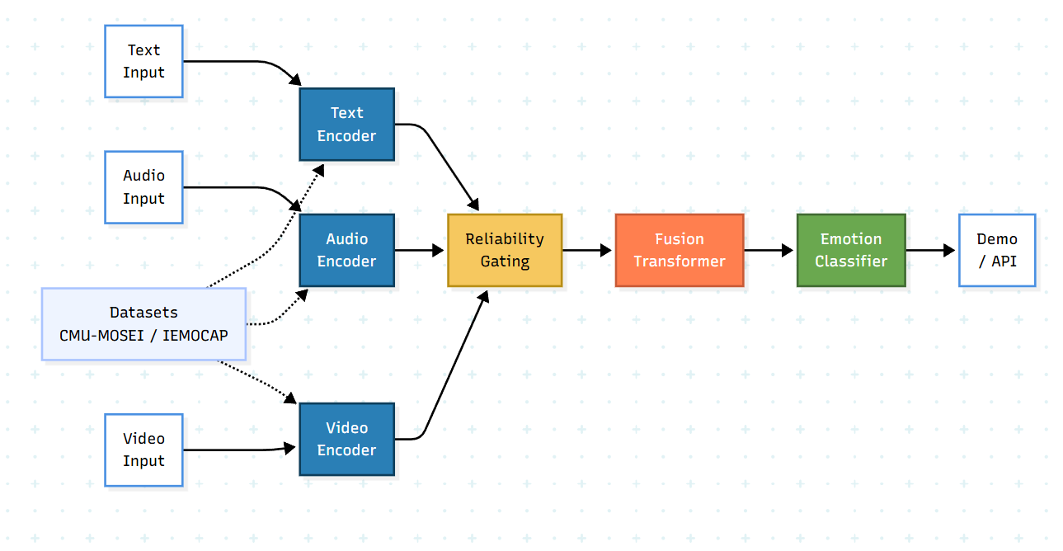
The overall architecture achieves an effective balance between several competing design objectives. It maintains high accuracy through the use of emotion-specific encoders and sophisticated fusion mechanisms, while keeping computational costs reasonable through efficient architectural choices and targeted fine-tuning strategies. It provides robustness through adaptive fusion and reliability-aware processing, while maintaining simplicity and clarity in the overall processing flow. It ensures flexibility for future extensions through modular design, while delivering immediately usable capabilities for current applications. This careful balance of objectives results in an architecture that is simultaneously powerful, practical, and extensible.
Figure 4. 1: System Architecture of the Multimodal Emotion Recognition System

4.2 Module Description
The multimodal emotion recognition system is organized into a carefully structured set of functional modules, where each module encapsulates a specific set of responsibilities within the overall emotion prediction pipeline. This modular organization enhances system clarity by providing clear separation of concerns, improves maintainability by allowing components to be understood and modified independently, and supports scalability by enabling new capabilities to be added through additional modules or extensions to existing ones. The following detailed descriptions explain the purpose, functionality, and implementation approach for each major module in the system.
- Text Processing Module: The Text Processing Module serves as the entry point for linguistic information into the emotion recognition pipeline and is responsible for transforming raw textual input into rich, emotion-aware semantic representations. This module handles all aspects of text encoding, from initial preprocessing and tokenization through contextual feature extraction using specialized transformer architectures. When textual input is received—whether typed directly by a user, extracted from documents, or transcribed from speech using automatic speech recognition systems—the module first applies tokenization to convert the continuous text string into a sequence of discrete tokens that are compatible with the transformer model. This tokenization process involves splitting text based on learned subword units, handling punctuation and special characters, and mapping each token to its corresponding identifier in the model's vocabulary. Alongside the token identifiers, the module generates attention masks that indicate which positions contain actual content versus padding added to meet fixed sequence length requirements. The tokenized input is then processed through an emotion-specific transformer-based language model that has been pre-trained on large-scale emotion and sentiment datasets. Unlike general-purpose language models that are trained primarily on objectives like masked language modelling or next sentence prediction using neutral text corpora, this specialized model has been exposed to text exhibiting a wide range of emotional expressions. This emotion-focused pre-training enables the model to develop internal representations that are particularly sensitive to affective linguistic features such as emotion words, intensifiers, negations, and sentiment-bearing constructions. The transformer encoder processes the input through multiple stacked layers, where each layer applies multi-head self-attention mechanisms followed by position-wise feed-forward networks. The self-attention mechanism allows each token to gather information from all other tokens in the sequence, weighted by learned attention scores that reflect semantic relevance. This contextualization process ensures that the representation of each word captures not only its inherent meaning but also how its interpretation is shaped by surrounding context. For example, the word "great" might be represented differently depending on whether it appears in "That's great news!" versus "That's just great..." where the latter might indicate sarcasm. The output of the text encoder is a sequence of contextualized embeddings, one for each input token, where each embedding is a high-dimensional vector that captures both the semantic content and the emotional colouring of the corresponding token in context. For classification purposes, the module typically extracts a fixed-size representation by either selecting the embedding corresponding to a special classification token (commonly denoted as [CLS]) or by applying pooling operations over the entire sequence. This final text embedding vector serves as a comprehensive semantic representation that encapsulates the emotional content conveyed through the linguistic channel and serves as input to subsequent fusion stages.
- Audio Processing Module: The Audio Processing Module is responsible for analysing speech input to extract acoustic and prosodic features that carry emotional information complementary to the linguistic content. This module handles the complete audio processing pipeline from raw signal acquisition through feature extraction using specialized speech emotion recognition models. The module accepts audio input in various formats, which may be uploaded from files, recorded in real-time through microphone input, or extracted from video sources. Initial preprocessing steps ensure that the audio meets the requirements of the emotion recognition model in terms of sampling rate, bit depth, and format. The raw audio waveform is typically resampled to a standard sampling rate (commonly 16kHz) to match the training conditions of the pre-trained audio encoder, and normalized to ensure consistent amplitude ranges across different recordings. The core of this module is a pre-trained speech emotion recognition model that has been specifically trained to recognize emotional cues in vocal expressions. This model analyses the audio signal to extract a comprehensive set of acoustic and prosodic features that correlate with different emotional states. Key features include fundamental frequency (F0) variations that reflect pitch contours and intonation patterns characteristic of different emotions—for instance, anger typically exhibits raised pitch and increased pitch range, while sadness often shows lowered pitch and reduced variability. Energy and intensity patterns indicate vocal effort and emotional arousal, with higher energy typically associated with emotions like excitement or anger, and lower energy with sadness or calmness. The model also captures spectral characteristics including formant frequencies, spectral centroid, and harmonic-to-noise ratio, which reflect voice quality and timbre changes associated with different emotional states. Temporal dynamics such as speaking rate, pause patterns, and rhythm provide additional cues—rapid speech might indicate excitement or anxiety, while slow, hesitant speech might suggest sadness or uncertainty. Advanced audio encoders often employ deep learning architectures such as convolutional neural networks that can learn hierarchical representations of audio spectrograms, or recurrent networks that capture temporal dependencies in the acoustic signal. Unlike general speech recognition models that focus primarily on extracting phonetic information for accurate transcription, this emotion-specific audio encoder emphasizes paralinguistic and prosodic features that carry affective information. The pre-training process involves exposing the model to large datasets of emotionally expressive speech, teaching it to recognize the acoustic patterns that distinguish different emotional states regardless of the specific words being spoken. The output of the audio encoder is a fixed-dimensional acoustic feature vector that captures the emotional quality of the vocal expression. This representation provides crucial information about how something was said—the affective prosody, vocal tone, and acoustic characteristics that convey emotional state beyond the literal meaning of words. This acoustic representation serves as the audio branch input to the multimodal fusion stage, where it will be integrated with semantic information from text to form a comprehensive multimodal emotion representation.
- Reliability Gating Module: The Reliability Gating Module represents a key innovation in the proposed system architecture, addressing the critical challenge of robustly handling inputs of varying quality and reliability. This module evaluates the relative informativeness and consistency of each modality's features and dynamically adjusts their contributions to the fusion process, ensuring that noisy or degraded inputs do not disproportionately influence final predictions. The module operates on the principle that in real-world scenarios, different modalities may exhibit widely varying quality and reliability. Audio might be degraded by background noise, acoustic interference, or poor recording equipment, while text might contain transcription errors, be incomplete, or lack clear emotional markers. Rather than treating all modality inputs as equally reliable regardless of their actual quality, this module learns to assess confidence indicators and adjust processing accordingly. The reliability assessment process employs learned neural network components that evaluate multiple quality indicators for each modality. For text features, assessment considers factors such as attention entropy (how focused versus diffuse the attention patterns are), feature variance (indicating richness of information), and consistency measures. For audio features, assessment examines signal-to-noise characteristics, prosodic feature consistency, and other quality indicators that can be computed from the feature representations. Based on these assessments, the module computes reliability scores for each modality using sigmoid activation functions that map the quality indicators to values between 0 and 1, where higher values indicate greater reliability. These scores serve as dynamic gates that modulate the magnitude of each modality's features before fusion. When one modality is assessed as highly reliable while the other shows quality issues, the gates adjust to emphasize the trustworthy modality while downweighting the problematic one. In ideal conditions where both modalities are of high quality, both gates remain open and allow full contribution from each source.
This dynamic gating mechanism provides crucial robustness benefits. When audio is clean and expressive, the system can leverage rich prosodic cues; when audio is noisy, the system gracefully reduces its dependence on acoustic information and relies more on textual semantic content. Conversely, when text is ambiguous, incomplete, or contains errors, the system can increase its reliance on the more reliable audio signal. This adaptive behaviour ensures that the system maintains accurate predictions across a wide range of input quality conditions rather than exhibiting catastrophic performance degradation when individual modalities are corrupted. The parameters of the reliability gating module are learned during training through backpropagation, allowing the system to automatically discover effective quality indicators and appropriate gating strategies. The training process exposes the module to inputs with varying quality levels, including augmented data with added noise or simulated degradation, teaching it to recognize quality issues and adjust gating appropriately. This learned approach is more effective than hand-crafted rules, as it can discover complex patterns in quality indicators that may not be obvious to human designers.
- Fusion Transformer Module: The Fusion Transformer Module serves as the integration core of the multimodal architecture, responsible for combining the modality-specific representations from text and audio into a unified multimodal representation that captures the full emotional context. This module employs sophisticated transformer-based processing with cross-modal attention mechanisms that enable deep, bi-directional interaction between modalities. The fusion process begins with the modality-specific features that have been reliability-gated by the previous module. These features are first processed to ensure dimensional compatibility—since text and audio encoders may produce embeddings of different dimensionalities, learned projection layers transform the features into a common embedding space. This projection is not merely a mechanical dimension-matching operation but a learned transformation that semantically aligns features from different modalities, mapping corresponding emotional expressions in text and audio to similar regions of the shared representation space. Once in a common space, the features are processed through transformer layers specifically configured for cross-modal fusion. Each fusion transformer layer contains two primary components: cross-modal attention sublayers and position-wise feed-forward networks. The cross-modal attention mechanism is the key innovation that enables sophisticated multimodal integration. Unlike standard self-attention that allows tokens within a single sequence to attend to each other, cross-modal attention allows features from one modality to attend to features from another modality. In practice, this bi-directional cross-attention operates in both directions: text features serve as queries that attend to audio features as keys and values, allowing the text representation to gather relevant information from the acoustic signal; simultaneously, audio features serve as queries attending to text features, allowing the acoustic representation to incorporate linguistic information. This mutual attention enables the model to discover and emphasize correspondences between modalities—for instance, associating emotionally charged words with corresponding prosodic expressions, or identifying mismatches such as positive words spoken with negative prosody that might indicate sarcasm. Through multiple layers of cross-attention and feed-forward processing, the fusion transformer builds increasingly abstract and integrated representations that capture complex cross-modal patterns. Early layers might identify basic correspondences such as high-arousal words aligning with energetic prosody, while deeper layers capture more subtle interactions such as how semantic content modulates the interpretation of ambiguous acoustic patterns, or how prosodic cues disambiguate emotionally unclear text. The architecture of the fusion transformer is carefully designed to balance expressiveness with computational efficiency. The number of layers, attention heads, and hidden dimensions are selected to provide sufficient capacity for learning complex multimodal interactions while avoiding excessive parameter counts that would increase computational costs and training difficulty. Residual connections and layer normalization techniques employed throughout the transformer structure facilitate stable gradient flow during training and enable effective learning in deep networks. The output of the fusion transformer is a unified multimodal embedding that synthesizes information from both text and audio into a coherent representation of the expressed emotion. This fused representation captures not only the individual emotional signals from each modality but also the interactions, reinforcements, and potential conflicts between modalities, providing a rich foundation for accurate emotion classification.
- Emotion Classification Module: The Emotion Classification Module receives the fused multimodal representation from the fusion transformer and produces the final emotion predictions along with associated confidence scores. This module implements the decision boundary that maps the high-dimensional fused features to discrete emotion categories. The classifier architecture consists of a sequence of fully connected (dense) layers that progressively transform the fused representation toward the final prediction. The first classification layer takes the fusion output and applies a linear transformation followed by non-linear activation (typically ReLU or GELU), reducing dimensionality while extracting task-relevant features. Batch normalization or layer normalization is applied to standardize activations and improve training stability, while dropout regularization randomly deactivates neurons during training to prevent overfitting and improve generalization. Additional hidden layers continue this pattern of linear transformation, normalization, activation, and dropout, each progressively refining the representation and adapting it to the specific emotion classification task. The depth and width of these layers are carefully chosen to provide sufficient representational capacity while avoiding excessive parameters that might lead to overfitting, particularly important given the limited size of emotion datasets compared to general language modelling corpora. The final classification layer applies a linear transformation that maps the processed features to a vector of logits—one for each target emotion category. In the current implementation targeting three emotions (happiness, sadness, anger), this final layer produces a three-dimensional logit vector. A softmax activation function is then applied to convert these logits into a proper probability distribution, where each element represents the model's estimated probability that the input expresses the corresponding emotion, and all probabilities sum to one. The predicted emotion label is determined by selecting the class with the highest probability (argmax operation). However, the complete probability distribution is retained and reported as confidence scores, providing valuable additional information beyond the discrete label. High confidence in the top prediction indicates that the model has strong evidence for that emotion, while more uniform distributions suggest ambiguity or mixed emotional content that the model is uncertain about. These confidence scores enable more nuanced interpretation of predictions and support downstream decision-making about how to use the results. During training, the classification module is optimized using cross-entropy loss that measures the discrepancy between predicted probability distributions and ground-truth emotion labels. To address class imbalance in training data, the loss is computed using class-specific weights that increase the penalty for errors on underrepresented emotions, encouraging the model to pay appropriate attention to all emotion categories rather than becoming biased toward common ones.
- User Interface Module: The User Interface Module provides the gateway through which end users interact with the emotion recognition system, enabling both technical and non-technical users to leverage the system's capabilities without requiring programming knowledge or familiarity with the underlying implementation details. This module translates between human-friendly interaction patterns and the technical interfaces of the underlying models. The primary manifestation of this module is a web-based interface implemented using the Gradio framework, which provides a clean, intuitive environment for emotion recognition interactions. The interface presents users with clear input mechanisms for both modalities: text can be typed directly into a text box or text area, providing immediate access to text-based emotion recognition; audio can either be uploaded from files stored on the user's device, supporting batch processing of recorded conversations, or recorded in real-time using the browser's microphone API, enabling live emotion analysis of spoken input. Once inputs are provided, users initiate emotion recognition by clicking a clearly labelled button, triggering the complete processing pipeline from input encoding through fusion to classification. The system processes the inputs and returns results typically within one or two seconds, providing near-instantaneous feedback suitable for interactive applications. Results are displayed in an easily interpretable format that shows both the predicted emotion label prominently highlighted and a visualization of confidence scores for all emotion categories, often represented as bar charts or percentage displays that allow users to quickly assess the model's certainty.
The interface design emphasizes usability and accessibility, employing clear labels, helpful tooltips, and intuitive layouts that guide users through the emotion recognition process. Error handling provides informative messages when issues occur—for example, if audio is in an unsupported format or if inputs are empty—helping users understand and resolve problems without technical assistance. The responsive design adapts to different screen sizes and devices, ensuring usable experiences on desktop computers, tablets, and smartphones.
Beyond the interactive web interface, the module can also provide programmatic API access through REST endpoints or Python function interfaces, enabling integration with other software systems. This programmatic access is essential for applications that need to process large volumes of data, integrate emotion recognition into existing workflows, or build more complex systems that incorporate emotion analysis as one component. The API provides the same core functionality as the web interface but in a format suitable for automated, programmatic access.
Documentation and example usage patterns are provided as part of this module, helping both interactive users and API consumers understand how to effectively utilize the system's capabilities. The combination of user-friendly interactive access for exploration and demonstration, along with robust API access for production integration, ensures that the emotion recognition system can serve diverse use cases and user populations effectively.

4.3 Data Flow Diagram (DFD)
The Data Flow Diagram provides a detailed visual representation of how data moves through the emotion recognition system from initial user input through all processing stages to final output generation. This diagram abstracts away implementation details to focus on the logical flow of information, illustrating which components process which data and how information is transformed at each stage.
The data flow begins with user input acquisition, where the system accepts two parallel streams of input data: textual content and audio recordings. These inputs may be provided through the web interface where users type text and upload or record audio, or through API calls where client applications submit data programmatically. The raw inputs enter the system as unprocessed text strings and audio waveforms that must be transformed into structured representations suitable for deep learning models.
The text processing stream receives the raw text input and performs several transformation steps. First, preprocessing normalizes the text by handling special characters, converting to appropriate case, and potentially cleaning transcription artifacts if the text originated from speech recognition. Next, tokenization converts the continuous text into a sequence of discrete tokens using the vocabulary of the emotion-specific text encoder. This tokenization produces two outputs: a sequence of token IDs that represent the actual content, and an attention mask that indicates which positions contain real tokens versus padding. These tokenized representations flow into the emotion-specific transformer encoder, which processes them through multiple attention and feed-forward layers. The encoder outputs a sequence of contextualized embeddings—one vector for each input token—from which a single fixed-size text representation is extracted through pooling or selection of a special classification token embedding.
Simultaneously, the audio processing stream handles the acoustic input through its own transformation pipeline. The raw audio waveform first undergoes preprocessing to ensure consistent format, including resampling to the target sampling rate, normalization of amplitude, and potentially segmentation if the audio is longer than the model's maximum input length. The pre-processed audio is then fed into the speech emotion recognition encoder, which may first compute spectral representations such as mel-spectrograms before processing through convolutional or recurrent layers. The audio encoder outputs a fixed-size acoustic feature vector that captures the prosodic and paralinguistic characteristics of the speech signal.
At this point, the data flow converges as the modality-specific representations—the text embedding and audio feature vector—enter the fusion pathway. First, these features are passed through the reliability gating module, which evaluates quality indicators and computes reliability scores for each modality. The gating module multiplies each feature vector by its corresponding reliability score, effectively scaling the features based on assessed quality. These reliability-weighted features then proceed to dimensional alignment where, if necessary, projection layers transform them into a common embedding space with compatible dimensionality.
The aligned features enter the fusion transformer, which applies cross-modal attention and feed-forward processing to integrate information across modalities. The cross-attention mechanism allows text features to query audio features and vice versa, creating rich interaction patterns. The output of the fusion transformer is a unified multimodal embedding vector that synthesizes information from both input streams. This fused representation flows into the emotion classification module, which processes it through fully connected layers with normalization and dropout. The final classification layer produces logits for each emotion category, which are converted to probabilities via softmax activation.
The output generation stage takes these prediction probabilities and formats them for presentation to the user. The predicted emotion label is determined by selecting the category with maximum probability, while the complete probability distribution is retained as confidence scores. These results—the discrete emotion label and the detailed confidence breakdown—are formatted appropriately for the output channel: rendered in the web interface with visualizations and clear labeling for interactive users, or returned as structured data (JSON or similar) for API consumers.
Throughout this data flow, several supporting processes operate in the background. Training data loading and preprocessing operate during the training phase, feeding batches of examples through the pipeline to optimize model parameters. Model checkpoint loading retrieves pre-trained encoder weights and previously learned fusion/classification parameters at system startup. Logging and monitoring processes track predictions, confidence scores, and system performance metrics for analysis and debugging purposes.
The DFD illustrates that the data flow is largely sequential and feed-forward from input to output, with parallel processing of text and audio streams that converge at the fusion stage. This structure supports efficient implementation where modality-specific processing can occur concurrently, and enables modular development where components can be implemented and tested independently before integration.

Figure 4. 2: Data Flow Diagram of the Emotion Recognition System

4.4 UML Diagrams
Unified Modelling Language (UML) diagrams provide standardized visual representations of the system from multiple perspectives, including user interactions, structural organization, and behavioural dynamics. These diagrams serve as important design documentation that clarifies system architecture and supports both implementation and maintenance activities.

4.4.1 Use Case Diagram
The Use Case Diagram illustrates the functional requirements of the emotion recognition system from the perspective of external actors—primarily end users—who interact with the system to accomplish specific goals. This diagram identifies the key use cases that the system supports and shows which actors are involved in each use case.
The primary actor in the system is the End User, representing any individual or system that interacts with the emotion recognition capabilities. The diagram shows several use cases that this actor can engage with:
"Submit Text Input" represents the use case where users provide textual content for emotion analysis. This might involve typing text directly into an interface, uploading text files, or providing text through an API call. The use case encompasses all activities related to text input submission, from initial entry through validation of format and length requirements.
"Submit Audio Input" similarly represents the provision of audio data for emotion analysis. Users might upload audio files from their devices, record audio in real-time using microphone input, or submit audio through programmatic API calls. This use case includes handling various audio formats, ensuring appropriate length and quality, and potentially converting between formats.
"View Emotion Prediction" represents the use case where users access and view the results of emotion classification. The system presents the predicted emotion label prominently, along with confidence scores for each possible emotion category. This use case includes formatting results appropriately for the output channel and potentially providing visualization elements such as charts or color-coded displays.
"Analyse Confidence Scores" represents a more detailed analysis use case where users examine the confidence distributions to understand the certainty of predictions. Users might compare confidence levels across emotions to identify cases of high certainty versus ambiguous predictions, or track confidence patterns across multiple inputs to understand system behaviour.
"Download Results" (if implemented) represents the ability to export prediction results in various formats for further analysis, reporting, or integration with other tools. This might include downloading results as CSV files, JSON documents, or formatted reports.
The diagram may also show relationships between use cases, such as "Submit Text Input" and "Submit Audio Input" both being specialized forms of a general "Submit Inputs" use case, or "View Emotion Prediction" including or extending "Analyse Confidence Scores" as a more detailed exploration of results.
A secondary actor that might be shown is the System Administrator, who engages with different use cases related to system maintenance, monitoring, and configuration. Administrator use cases might include "Monitor System Performance," "Update Model Weights," "Configure System Parameters," and "View Usage Logs."
The Use Case Diagram provides a high-level view of system functionality from the user perspective, helping stakeholders understand what the system does and how users interact with it, without delving into implementation details.
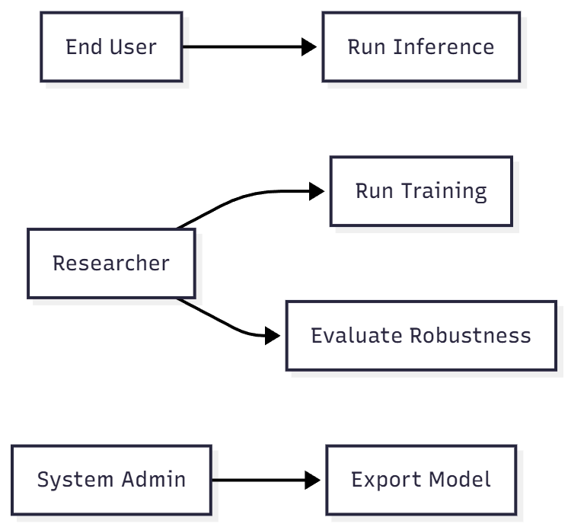
Figure 4. 3: Use Case Diagram

4.4.2 Class Diagram
The Class Diagram represents the structural organization of the system at the object-oriented programming level, showing the major classes that comprise the implementation, their attributes and methods, and the relationships between classes. This diagram provides a blueprint for the software architecture that guides implementation and maintenance.
The diagram identifies several key classes that correspond to the major functional modules:
- TextEncoder class encapsulates the text processing functionality. Its attributes include the pre-trained transformer model instance, tokenizer for converting text to tokens, maximum sequence length, and configuration parameters. Key methods include encode_text(text_input) which processes raw text and returns embeddings, tokenize(text) which handles tokenization, and potentially load_pretrained_model() for initialization.
- AudioEncoder class handles audio processing with attributes for the speech emotion recognition model, sampling rate, and audio preprocessing parameters. Methods include encode_audio(audio_input) which processes audio signals and returns acoustic feature vectors, preprocess_audio(raw_audio) which handles format conversion and normalization, and feature extraction utilities.
- ReliabilityGate class implements the reliability assessment and gating mechanism. Attributes include learned gating network parameters and quality assessment thresholds. Methods include compute_reliability(text_features, audio_features) which assesses modality quality and returns reliability scores, and apply_gating(features, reliability_scores) which modulates features based on reliability.
- FusionTransformer class represents the multimodal fusion module with attributes for transformer layers, cross-attention mechanisms, and projection layers. Key methods include fuse_modalities(text_features, audio_features) which integrates multimodal representations, cross_modal_attention() which implements the attention mechanism, and potentially methods for each transformer layer.
- EmotionClassifier class implements the classification functionality with attributes for fully connected layers, dropout rates, and output dimension (number of emotion classes). Methods include classify(fused_features) which produces emotion predictions and confidence scores, forward(features) implementing the forward pass through classification layers, and potentially compute_loss(predictions, labels) for training.
- MultimodalEmotionRecognizer class serves as the main orchestrator that composes the other classes into a complete system. Attributes include instances of the encoder, gating, fusion, and classifier classes, along with system configuration parameters. Methods include predict(text, audio) as the main entry point that coordinates the entire pipeline, train_model(dataset) for training, load_checkpoint(path) and save_checkpoint(path) for model persistence, and evaluate(test_dataset) for performance assessment.
- DataLoader class handles dataset management with attributes for dataset paths, batch size, and preprocessing configurations. Methods include load_batch() for retrieving training examples, preprocess_dataset() for data preparation, and iterators for training loops.
- UserInterface class represents the web interface layer with attributes for Gradio components and interface configuration. Methods include launch_interface() to start the web server, handle_user_input() to process submitted data, and display_results() to format outputs for presentation.
The diagram shows relationships between classes including:
- Composition: MultimodalEmotionRecognizer contains instances of TextEncoder, AudioEncoder, ReliabilityGate, FusionTransformer, and EmotionClassifier
- Dependency: Various classes depend on shared utilities or configuration classes
- Inheritance: Potentially showing that specialized encoder classes inherit from a base Encoder class
- Association: UserInterface associates with MultimodalEmotionRecognizer to invoke predictions
This structural view helps developers understand the system's organization, guides implementation by clarifying responsibilities and interfaces, and supports maintenance by documenting the relationships between components.
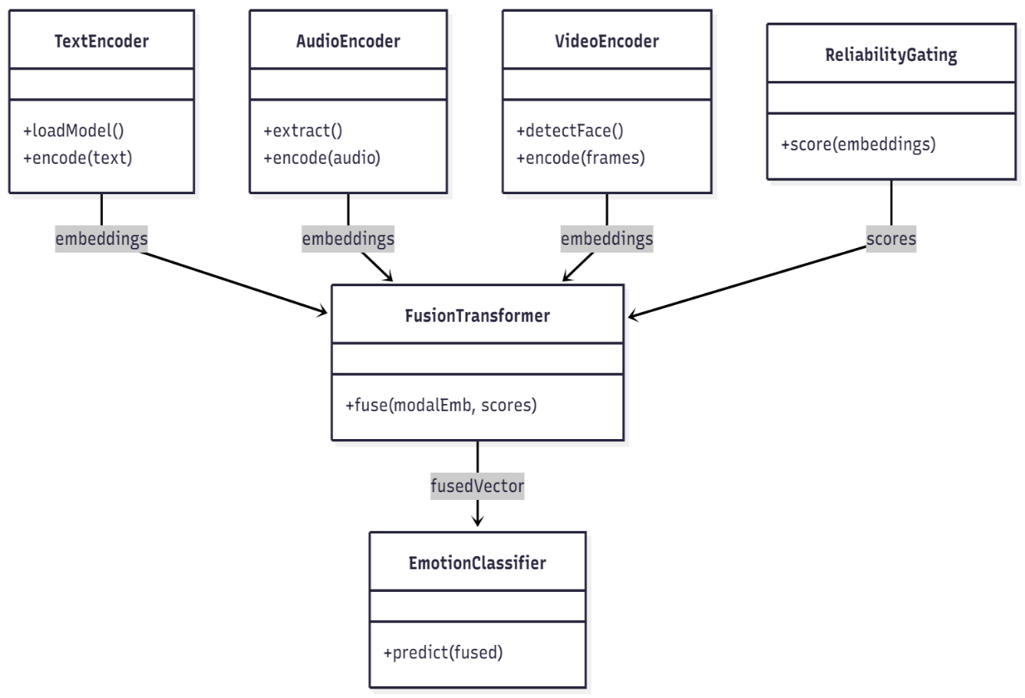
Figure 4. 4: Class Diagram of the System

4.4.3 Sequence Diagram
The Sequence Diagram depicts the temporal sequence of interactions between system components during the emotion prediction process. This behavioural diagram shows the step-by-step message passing and method invocations that occur from the moment a user submits input until results are returned, providing insight into the runtime dynamics of the system.
The diagram identifies several participating objects or actors:
- User (actor): The external entity initiating the interaction
- UserInterface: The interface layer that receives user requests
- MultimodalEmotionRecognizer: The main orchestrator
- TextEncoder: Text processing component
- AudioEncoder: Audio processing component
- ReliabilityGate: Quality assessment component
- FusionTransformer: Multimodal integration component
- EmotionClassifier: Classification component
The interaction sequence proceeds as follows:
- User → UserInterface: The sequence begins when the user submits text and audio inputs through the interface by clicking a prediction button or calling an API endpoint.
- UserInterface → MultimodalEmotionRecognizer: The interface calls the predict(text, audio) method on the main recognizer object, passing the user-provided inputs.
- MultimodalEmotionRecognizer → TextEncoder: The recognizer forwards the text input to the text encoder by calling encode_text(text).
- TextEncoder → TextEncoder: Internal processing occurs as the encoder tokenizes the input and processes it through transformer layers (shown as a self-call or internal activation).
- TextEncoder → MultimodalEmotionRecognizer: The text encoder returns the computed text embeddings.
- MultimodalEmotionRecognizer → AudioEncoder: Simultaneously (shown with parallel lifelines), the recognizer calls encode_audio(audio) on the audio encoder.
- AudioEncoder → AudioEncoder: Internal processing occurs as the encoder preprocesses the audio and extracts features.
- AudioEncoder → MultimodalEmotionRecognizer: The audio encoder returns acoustic features.
- MultimodalEmotionRecognizer → ReliabilityGate: The recognizer calls compute_reliability(text_features, audio_features) to assess modality quality.
- ReliabilityGate → MultimodalEmotionRecognizer: Reliability scores are returned for each modality.
- MultimodalEmotionRecognizer → ReliabilityGate: The recognizer calls apply_gating(features, scores) to modulate features based on reliability.
- ReliabilityGate → MultimodalEmotionRecognizer: Gated features are returned.
- MultimodalEmotionRecognizer → FusionTransformer: The recognizer calls fuse_modalities(text_features, audio_features) with the gated features.
- FusionTransformer → FusionTransformer: Internal cross-modal attention and fusion processing occurs.
- FusionTransformer → MultimodalEmotionRecognizer: The fused multimodal representation is returned.
- MultimodalEmotionRecognizer → EmotionClassifier: The recognizer calls classify(fused_features) to obtain predictions.
- EmotionClassifier → EmotionClassifier: Classification layers process the features.
- EmotionClassifier → MultimodalEmotionRecognizer: Emotion predictions and confidence scores are returned.
- MultimodalEmotionRecognizer → UserInterface: The recognizer returns the complete results to the interface.
- UserInterface → User: The interface formats and displays the emotion prediction and confidence scores to the user.
The diagram uses standard UML sequence notation with vertical lifelines representing the existence of each object over time, horizontal arrows representing messages or method calls between objects, and activation boxes showing when an object is actively processing. The sequential ordering from top to bottom represents the temporal flow of execution.
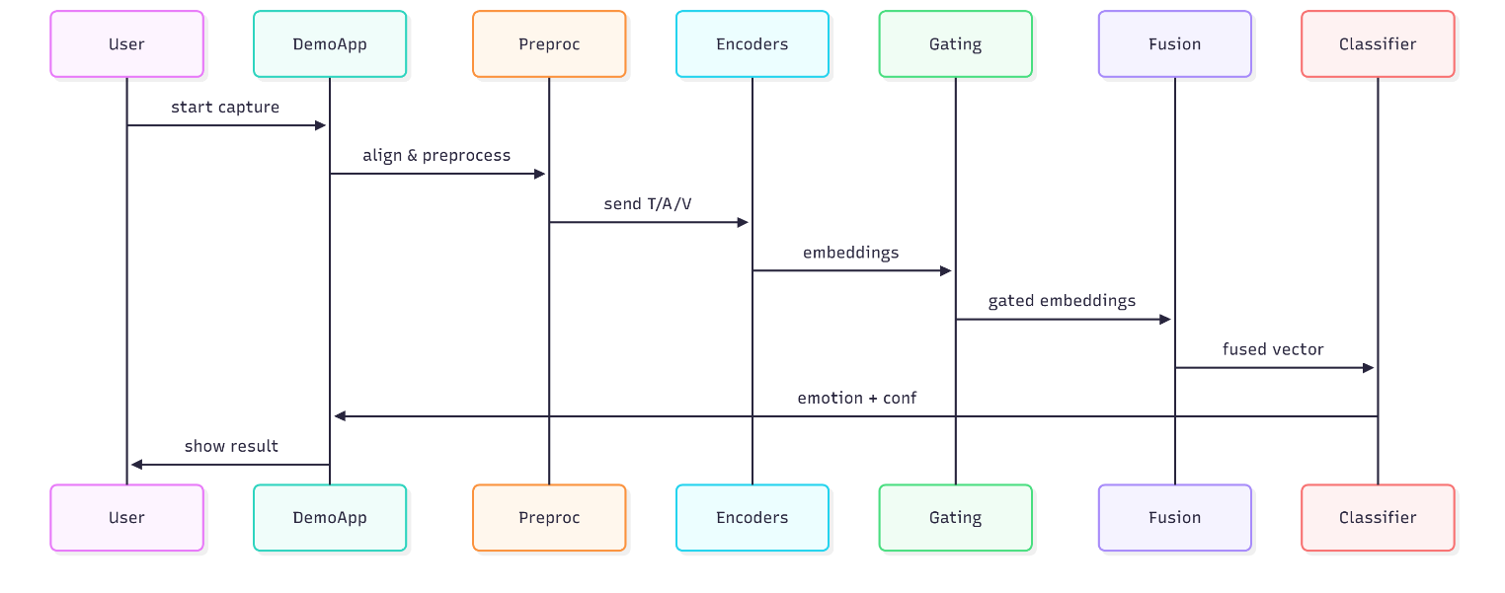
This sequence diagram clarifies the dynamic behaviour of the system, showing exactly how components collaborate to transform inputs into outputs. It helps developers understand the runtime interactions, supports debugging by showing the expected call sequence, and aids in identifying performance bottlenecks by revealing which operations occur sequentially versus in parallel.

Figure 4. 5: Sequence Diagram for Emotion Prediction

4.5 Database Design (Logical Storage)
The multimodal emotion recognition system employs a non-traditional approach to data persistence that differs significantly from conventional database-driven applications. Rather than utilizing a relational database management system (RDBMS) with normalized tables and SQL queries, the system relies on filesystem-based logical storage mechanisms that are well-suited to the characteristics of deep learning applications. This design choice reflects the nature of the data being managed and the access patterns required during development, training, and inference.
Storage Components and Organization
The logical storage system is organized around several distinct categories of data, each with specific format and access requirements:
- Pre-processed Datasets represent the largest storage component and contain the training, validation, and test examples that have been pre-processed and transformed into formats suitable for efficient batch loading during model training. Rather than storing raw text and audio files that would require repeated preprocessing, the system stores pre-processed data in NPZ format (NumPy's compressed archive format). Each NPZ file contains multiple named arrays including tokenized text sequences, attention masks, pre-processed audio features or spectrograms, emotion labels, and metadata. This format enables extremely fast loading during training since data is already in the exact format required by the model, and NumPy's compression reduces storage space compared to uncompressed arrays. The dataset storage is typically organized hierarchically with separate directories for different datasets (CMU-MOSEI, IEMOCAP, etc.) and separate files for training, validation, and test splits.
- Model Checkpoints store the learned parameters of the emotion recognition system at various points during training. Each checkpoint is a serialized file (typically using PyTorch's .pt or .pth format) containing the complete state dictionary of the model—all weights and biases for the encoders, fusion transformer, and classifier components. Checkpoints also include optimizer state information (momentum values, learning rate schedules, etc.) to enable training to be resumed from the exact point where it was interrupted. Additionally, checkpoints store training metadata such as the current epoch number, training loss history, and validation metrics. The checkpoint system enables several important capabilities: saving the best-performing model based on validation metrics, implementing early stopping to prevent overfitting, recovering from training interruptions without starting from scratch, and maintaining a history of model evolution throughout training for analysis purposes.
- Configuration Files store system parameters, hyperparameters, and training settings in human-readable JSON or YAML format. These configurations specify model architecture details (number of layers, hidden dimensions, attention heads), training hyperparameters (learning rates, batch sizes, number of epochs), data processing parameters (maximum sequence lengths, audio sampling rates), and paths to data and checkpoint files. Using external configuration files rather than hard-coding parameters in source code enables easy experimentation with different settings, supports reproducibility by documenting exact configurations used for each experiment, and allows multiple configurations to coexist for different use cases or deployment scenarios.
- Training Logs and Metrics capture the evolution of the model during training in structured text files or JSON format. These logs record training loss, validation loss, accuracy, F1 scores, and other metrics at regular intervals (typically each epoch or batch). The logged information supports several important functions: monitoring training progress to identify issues such as overfitting or failure to converge, comparing different training runs to evaluate the impact of hyperparameter changes, generating training curves and visualizations for analysis and presentation, and debugging by identifying exactly when and how training behaviour changed.
- Inference Cache (optional) stores predictions and intermediate features for commonly accessed inputs to accelerate repeated inference. When the system is deployed as a service that may receive repeated queries for the same inputs, caching can significantly reduce response latency and computational load by retrieving stored results rather than recomputing predictions. The cache is typically implemented using simple key-value storage where the key is a hash of the input and the value is the corresponding prediction and confidence scores.
Storage Design Rationale
The decision to use filesystem-based logical storage rather than a traditional database is motivated by several factors specific to deep learning applications:
- Access Patterns: Deep learning training involves sequential reading of large batches of examples from disk into memory, where they are then fed to GPUs for processing. This access pattern—bulk sequential reads of entire datasets—is exactly what filesystem storage with large files excels at, whereas databases optimized for random access of individual records would provide no benefit and would introduce overhead.
- Data Format: The data being stored consists primarily of high-dimensional numeric arrays (embeddings, features, model weights) that have natural serialization formats (NPZ, PyTorch checkpoints) specifically designed for efficient storage and loading of array data. These specialized formats are more efficient than attempting to store large arrays in database BLOB fields.
- Simplicity: Filesystem storage eliminates the complexity of database installation, configuration, and maintenance. The system can be deployed on any machine with a filesystem, without requiring database server software or administration. This simplicity reduces deployment barriers and makes the system more accessible to users with varied technical backgrounds.
- Portability: Checkpoint files and pre-processed datasets stored in standard formats can be easily copied between machines, uploaded to cloud storage, or shared between researchers, enabling collaboration and reproducibility. Database-stored data would require export and import procedures or access to the same database system.
- Tool Ecosystem: The deep learning ecosystem provides extensive tooling for working with filesystem-based storage, including data loaders, checkpointing utilities, and monitoring tools, all of which assume filesystem storage. Adapting these tools to work with databases would require significant additional engineering.
Data Flow During Training and Inference
During training, the system follows this storage access pattern:
- Load pre-processed dataset from NPZ files into memory/GPU memory in batches
- Process each batch through the model forward pass
- Compute loss and perform backward pass to generate gradients
- Update model parameters using optimizer
- Periodically (each epoch) evaluate validation performance
- If validation performance improves, save current model state as a checkpoint
- Log training metrics to log files
- Repeat until training completion or early stopping
During inference, the access pattern is:
- Load trained model weights from checkpoint file at system startup
- Receive user inputs (text and audio)
- Preprocess inputs into model-compatible format
- Process through loaded model to generate predictions
- Optionally cache predictions for this input
- Return results to user
This logical storage design provides an efficient, simple, and practical foundation for managing the data requirements of the emotion recognition system throughout development, training, deployment, and operational use.
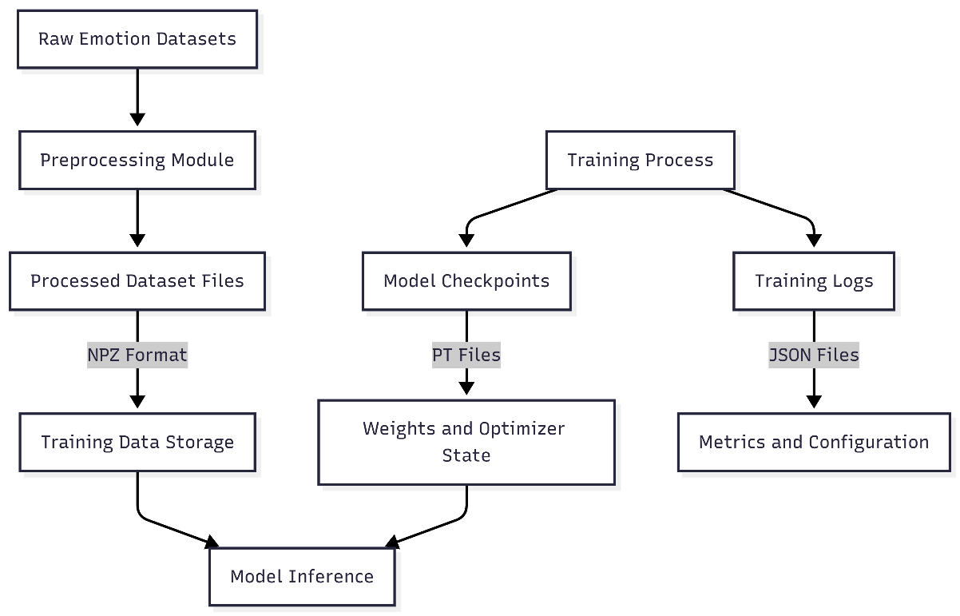
Figure 4. 6: Logical Data Storage Design

5. Implementation

5.1 Technology Stack Used
The implementation of the multimodal emotion recognition system leverages a carefully selected ensemble of modern deep learning frameworks, libraries, and development tools that together provide the capabilities required for building, training, and deploying sophisticated multimodal models. Each technology in the stack serves specific purposes and has been chosen based on considerations of functionality, maturity, community support, and compatibility with the overall system architecture.
Python serves as the primary programming language for the entire system implementation, chosen for its dominant position in the machine learning and data science ecosystem. Python's extensive library support, readable syntax, and strong community make it the natural choice for deep learning applications. The implementation uses Python 3.10 or later to take advantage of modern language features, performance improvements, and compatibility with current library versions.
PyTorch functions as the core deep learning framework providing the fundamental building blocks for implementing neural network architectures, automatic differentiation for gradient computation, and efficient GPU-accelerated tensor operations. PyTorch's dynamic computational graph model, which builds the computation graph on-the-fly during forward passes, provides flexibility that is particularly valuable when implementing complex architectures with conditional logic or dynamic components like the reliability gating mechanism. PyTorch's extensive ecosystem includes tools for distributed training, model optimization, and deployment that support the complete lifecycle of deep learning model development. The framework's integration with CUDA enables seamless GPU acceleration, dramatically reducing training and inference time compared to CPU-only execution.
HuggingFace Transformers library provides standardized access to hundreds of pre-trained transformer models and associated utilities. This library abstracts away many implementation details of transformer architectures, tokenization, and model loading, enabling developers to leverage state-of-the-art pre-trained models with minimal code. For this project, the Transformers library provides access to emotion-specific text encoders and speech emotion recognition models that serve as the foundation for modality-specific feature extraction. The library's unified API across different model architectures simplifies experimentation with alternative encoder choices and ensures compatibility with community-contributed models. Additional utilities for tokenization, padding, attention masking, and configuration management further streamline implementation.
Librosa handles audio processing tasks, providing comprehensive functionality for loading audio files, extracting acoustic features, and performing spectral analysis. This well-established library offers efficient implementations of common audio processing operations including resampling, Fourier transforms, mel-spectrogram computation, pitch extraction, and tempo estimation. Librosa's integration with NumPy and its support for various audio formats make it a natural fit for preprocessing audio inputs before they are fed to the speech emotion recognition encoder.
SoundFile complements Librosa by providing fast, reliable audio I/O capabilities. While Librosa includes audio loading functionality, SoundFile offers superior performance for reading and writing audio files in various formats including WAV, FLAC, and OGG. The library's lightweight design and focus on I/O operations make it particularly suitable for efficiently handling audio data during both training and inference.
scikit-learn provides essential utilities for model evaluation, metric computation, and data preprocessing tasks. The library's implementations of classification metrics including accuracy, precision, recall, F1 score, and confusion matrices enable comprehensive evaluation of model performance. Additional functionality for data splitting, class balancing, and preprocessing supports various aspects of the training pipeline. scikit-learn's well-tested, efficient implementations ensure that evaluation and preprocessing operations are both correct and performant.
Gradio enables rapid development of interactive web interfaces for machine learning models without requiring extensive web development expertise. This framework automatically generates clean, functional web UIs from simple Python function definitions, handling all the HTML, CSS, JavaScript, and server infrastructure behind the scenes. For this project, Gradio creates the demonstration interface that allows users to input text and audio, trigger emotion predictions, and view results with minimal development effort. The framework's built-in support for various input and output types (text boxes, audio uploads, microphone recording, labels, confidence scores) perfectly matches the requirements of the emotion recognition interface. Gradio also provides sharing capabilities that enable deployed interfaces to be accessed remotely, facilitating demonstrations and user testing.
NumPy provides the foundational array computation capabilities that underlie much of the scientific Python ecosystem. While PyTorch tensors are used for neural network operations, NumPy arrays are employed extensively for data preprocessing, batching, and intermediate computations during data loading and evaluation. NumPy's efficient array operations and broad compatibility with other libraries make it an essential component of the technology stack.
Matplotlib and Seaborn (potentially used) support visualization of training curves, confusion matrices, attention weights, and other analytical outputs that aid in understanding model behavior and performance. These visualization libraries enable creation of publication-quality plots and figures for documentation and analysis.
The technology stack is unified by strong interoperability—PyTorch integrates seamlessly with NumPy, Transformers is built on PyTorch, Librosa outputs NumPy arrays compatible with PyTorch, and Gradio can directly wrap PyTorch models. This cohesive ecosystem minimizes integration challenges and enables developers to focus on model architecture and training strategies rather than wrestling with incompatible data formats or APIs.
Technologies Used Summary:
- Programming Language: Python 3.10+
- Deep Learning Framework: PyTorch (with CUDA support)
- Transformer Models: HuggingFace Transformers
- Audio Processing: Librosa, SoundFile
- Web Interface: Gradio
- Evaluation and Metrics: scikit-learn
- Array Computation: NumPy
- Visualization: Matplotlib, Seaborn
This technology stack represents a carefully balanced selection that combines maturity and reliability with cutting-edge capabilities, ensuring that the implementation benefits from well-tested tools while remaining at the forefront of deep learning technology.

5.2 Hardware and Software Requirements
Hardware Requirements
The hardware requirements have been carefully validated through actual implementation and testing, demonstrating that sophisticated multimodal emotion recognition can be achieved without requiring expensive high-end computing infrastructure.
- Processor: A modern multi-core processor from Intel or AMD is required to handle the CPU-based operations including data preprocessing, batch preparation, model initialization, and various overhead tasks that don't execute on the GPU. While the specific processor model is not critical, processors from the last 5-7 years with at least 4 cores are recommended. The actual training computations are GPU-accelerated and thus relatively insensitive to CPU performance, but a capable processor ensures that data loading and preprocessing do not become bottlenecks that leave the GPU idle waiting for data.
- GPU: An NVIDIA GPU with CUDA support is essential for efficient training and inference. The system was successfully developed and validated using an NVIDIA RTX 4050 laptop GPU with 6GB of video memory (VRAM), demonstrating that consumer-grade mobile GPUs provide sufficient computational capability for this application. The RTX 4050 offers several advantages including support for mixed precision training through tensor cores that accelerate computation while reducing memory usage, adequate memory capacity to fit model parameters and training batches, and good power efficiency suitable for laptop deployment. While more powerful GPUs like RTX 4060, 4070, or higher-end options would accelerate training, they are not required—the RTX 4050 proves sufficient, though training times will be longer compared to high-end hardware. For inference only (not training), even older or lower-end GPUs with 4GB+ VRAM may be adequate depending on batch size requirements.
- RAM: A minimum of 16GB of system RAM is strongly recommended to support comfortable development and training operations. System memory is used for storing pre-processed datasets before they are transferred to GPU memory, maintaining the Python interpreter and libraries, running development tools and IDEs, and buffering during data loading operations. While it may be possible to train with 8GB of RAM using careful memory management and reduced batch sizes, 16GB provides headroom for efficient operation without constant memory pressure. For larger-scale training or working with multiple models simultaneously, 32GB would provide additional comfort.
- Storage: Approximately 20GB of free disk space is required to accommodate the various components of the system. This space allocation includes pre-trained model weights (typically 500MB-2GB per model), pre-processed datasets in compressed NPZ format (several GB depending on dataset size), model checkpoints saved during training (each checkpoint ~500MB-1GB), training logs and evaluation metrics, and the Python environment with all installed libraries. Using solid-state drive (SSD) storage is highly recommended over traditional hard disk drives (HDD) as the faster I/O speeds of SSDs significantly reduce data loading times during training, particularly when loading large pre-processed datasets from disk into memory.

Software Requirements
The software environment encompasses the operating system, Python runtime, GPU drivers and libraries, and the specific Python packages that comprise the technology stack.
- Operating System: The system was developed and tested on Windows 10/11, but the implementation is not operating system-specific due to the cross-platform nature of Python and PyTorch. The system should function equally well on Linux distributions (Ubuntu, Fedora, etc.) and macOS, though macOS users should note that NVIDIA GPU acceleration is not available on Apple hardware—macOS users would need to adapt the system to use CPU-only execution or Metal Performance Shaders if supported.
- Python Version: Python 3.10 or newer is required to ensure compatibility with current versions of PyTorch, Transformers, and other dependencies. Python 3.10 introduced performance improvements, better type annotations, and other language enhancements that benefit the implementation. Using the latest stable Python version (3.11 or 3.12 as of this writing) is recommended unless specific library compatibility issues arise.
- CUDA Toolkit: CUDA 11.8 or compatible version is required to enable GPU acceleration of PyTorch operations. The CUDA toolkit provides the low-level drivers and libraries that allow PyTorch to utilize NVIDIA GPU hardware for tensor operations. The specific CUDA version should match the PyTorch installation—PyTorch releases are compiled against specific CUDA versions, so it's important to install a PyTorch build compatible with the available CUDA version. CUDA 11.8 represents a stable, widely supported version at the time of development, though newer CUDA versions (12.x) may offer improved performance if compatible PyTorch builds are available.
- Python Libraries and Dependencies: The following Python packages must be installed in the Python environment:
- torch (PyTorch): Core deep learning framework—install version compatible with available CUDA (e.g., PyTorch 2.0+ with CUDA 11.8 support)
- transformers: HuggingFace library for pre-trained models—latest stable version (4.30+)
- librosa: Audio processing library—version 0.10.0+
- soundfile: Audio I/O—version 0.12.0+
- gradio: Web interface framework—version 3.35+
- scikit-learn: Metrics and evaluation—version 1.3.0+
- numpy: Array operations—version 1.24+
- tqdm: Progress bars for training monitoring
- accelerate: Training optimization utilities (optional but recommended)
- datasets: HuggingFace datasets library for benchmark data access (if using HF datasets)
These dependencies can be installed using pip or conda package managers, with pip being the most straightforward approach. A requirements.txt file listing all dependencies with version specifications enables reproducible environment setup across different machines.

Development and Training Performance Characteristics
The validated hardware configuration (Intel/AMD multi-core CPU, RTX 4050 6GB GPU, 16GB RAM) provides the following approximate performance characteristics based on actual implementation experience:
- Training with Frozen Encoders: When using the two-phase training strategy with frozen pre-trained encoders, training the fusion and classification layers requires significantly reduced time compared to full fine-tuning—typically several hours for a complete training run on standard-size emotion datasets. The frozen encoders mean that only the smaller fusion and classification components are being updated, dramatically reducing the computational workload and memory requirements.
- Training with Gradual Unfreezing: When gradually unfreezing encoder layers to perform task-specific fine-tuning, training time increases substantially—potentially 10-20 hours or more for complete training depending on dataset size and number of epochs. However, this increased training time results in improved accuracy as the pre-trained representations adapt to the specific characteristics of emotion recognition tasks. Mixed precision training and gradient accumulation are essential during this phase to keep memory usage within the 6GB VRAM constraint while maintaining effective batch sizes.
- Inference Performance: Once trained, the system performs inference (prediction on new inputs) very efficiently, typically processing inputs and generating predictions in 1-2 seconds on the RTX 4050 GPU, well within real-time requirements for interactive applications. Batch inference on multiple examples simultaneously can achieve even higher throughput.
This demonstration that the system can be successfully trained and deployed on a consumer laptop with a mid-range mobile GPU represents a significant achievement in accessibility, proving that advanced multimodal emotion recognition does not require prohibitively expensive infrastructure and can be developed and deployed by individuals and small teams without access to high-performance computing facilities.

5.3 Algorithm / Model Description
The emotion recognition model implements a sophisticated multimodal learning architecture that strategically integrates information from text and audio modalities through a carefully designed processing pipeline. This section provides a detailed algorithmic description of how the model transforms raw inputs into emotion predictions through a series of encoding, fusion, and classification operations.
Text Processing and Encoding
The text branch of the model processes linguistic input to extract semantic representations that capture emotional content conveyed through language. The algorithm proceeds as follows:
- Input Reception: Raw text input $T$is received as a string of characters or words expressing an emotional statement.
- Tokenization: The text is processed through a tokenizer $τ$specific to the pre-trained text encoder, which converts the text into a sequence of tokens: $[t_{1},t_{2},...,t_{n}]=τ(T)$, where $n$is the sequence length. The tokenizer employs subword tokenization (typically WordPiece or BPE) to handle vocabulary coverage and out-of-vocabulary words.
- Special Token Addition: Special tokens are added following the model's requirements—typically a classification token [CLS] at the beginning and a separator token [SEP] at the end: $\left[CLS , t_{1} , t_{2} , ... , t_{n} , SEP\right]$.
- Attention Mask Creation: An attention mask $M_{\text{text}}$is generated indicating which positions contain actual tokens (value 1) versus padding (value 0) for batch processing.
- Embedding and Encoding: The token sequence is processed through the emotion-specific transformer encoder $ϕ_{\text{text}}$, which consists of multiple stacked transformer layers. Each layer applies multi-head self-attention followed by position-wise feed-forward networks:
$$H^{\left(l\right)}=\text{LayerNorm}(H^{\left(l − 1\right)}+\text{MultiHeadAttention}(H^{\left(l − 1\right)}))$$
where $H^{\left(l\right)}$represents the hidden states at layer $l$.
- Feature Extraction: From the final layer's output, a fixed-size text representation $f_{\text{text}}∈R^{d_{\text{text}}}$is extracted, typically by selecting the embedding corresponding to the [CLS] token or by applying pooling operations over all token embeddings.
The resulting text feature vector $f_{\text{text}}$encodes the semantic and affective content of the linguistic input in a contextualized representation that captures not only individual word meanings but also compositional semantics and emotional connotations.
Audio Processing and Encoding
The audio branch processes speech signals to extract prosodic and acoustic features that complement the semantic information from text:
- Input Reception: Raw audio input $A$is received as a waveform or audio file containing speech.
- Preprocessing: The audio undergoes preprocessing including:
  - Resampling: Converting to the target sampling rate $f_{s}$(typically 16kHz) to match encoder expectations
  - Normalization: Scaling amplitude to a standard range
  - Segmentation: Trimming silence and potentially segmenting long audio into fixed-length chunks
- Feature Computation: Depending on the audio encoder architecture, the raw waveform may be directly processed or first transformed into spectral representations such as mel-spectrograms $S$computed via Short-Time Fourier Transform (STFT) and mel-filterbank application.
- Encoding: The preprocessed audio or spectral features are processed through the speech emotion recognition encoder $ϕ_{\text{audio}}$, which may employ convolutional networks, recurrent networks, or transformers specifically designed for audio:
$$f_{\text{audio}}=ϕ_{\text{audio}}(A)$$
The encoder learns to extract hierarchical features capturing low-level acoustic characteristics (pitch, energy, spectral shape) and higher-level prosodic patterns (intonation contours, rhythm, speaking style).
- Feature Extraction: The encoder outputs a fixed-size acoustic feature vector $f_{\text{audio}}∈R^{d_{\text{audio}}}$that encodes the emotional characteristics of the vocal expression.
Reliability Assessment and Gating
A critical component of the algorithm is the adaptive assessment of modality reliability:
- Quality Evaluation: The reliability gating module $γ$evaluates features from both modalities to estimate their quality and informativeness:
$$r_{\text{text}}=σ(w_{\text{text}}^{T}f_{\text{text}}+b_{\text{text}})$$
where $σ$is the sigmoid activation function, $w$are learned weight vectors, and $b$are biases. The reliability scores $r_{\text{text}},r_{\text{audio}}∈(0,1)$indicate estimated quality.
- Feature Gating: The features are modulated by their reliability scores:
$${\tilde{f}}_{\text{text}}=r_{\text{text}}⋅f_{\text{text}}$$
Multimodal Fusion
The gated features from both modalities are integrated through cross-modal attention and fusion:
- Dimensional Alignment: If the text and audio feature dimensions differ, projection layers align them to a common dimension $d$:
$$h_{\text{text}}=W_{\text{text}}{\tilde{f}}_{\text{text}}+b_{\text{text}}$$
- Cross-Modal Attention: Bidirectional cross-attention allows each modality to attend to the other
- Fusion: The attended representations are combined through concatenation or addition:
$$h_{\text{fused}}=[h_{\text{text}}∣∣{\text{Attn}}_{\text{text→audio}}∣∣h_{\text{audio}}∣∣{\text{Attn}}_{\text{audio→text}}]$$
or alternative fusion strategies. The fused representation is then processed through transformer layers $ϕ_{\text{fusion}}$:
$$z=ϕ_{\text{fusion}}(h_{\text{fused}})$$
producing the final multimodal representation $z∈R^{d_{\text{fusion}}}$.
Classification
The fused representation is mapped to emotion predictions:
- Classification Layers: The fused features pass through fully connected layers with activation and regularization:
$$h_{\text{cls}}^{\left(1\right)}=\text{Dropout}(\text{ReLU}(W_{1}z+b_{1})$$
- Output Layer: The final layer produces logits for each emotion class:
$$o=W_{\text{out}}h_{\text{cls}}^{\left(2\right)}+b_{\text{out}}$$
where $o∈R^{C}$and $C$is the number of emotion classes (3 in this case: happiness, sadness, anger).
- Probability Computation: Softmax activation converts logits to probabilities:
$$P(y=c∣f_{\text{text}},f_{\text{audio}})=\frac{exp⁡(o_{c})}{\sum_{j=1}^{C}{exp⁡(}o_{j})}$$
- Prediction: The predicted emotion is the class with maximum probability:
$$\hat{y}=arg⁡\underset{c}{max⁡}P(y=c∣f_{\text{text}},f_{\text{audio}})$$
Training Strategy
The model is trained using a two-phase approach designed to balance efficiency with performance:
Phase 1 - Frozen Encoders:
- The pre-trained text and audio encoders $ϕ_{\text{text}},ϕ_{\text{audio}}$are frozen (parameters fixed)
- Only the reliability gating $γ$, fusion transformer $ϕ_{\text{fusion}}$, and classifier parameters are trainable
- This phase trains quickly as only a subset of parameters are updated
- The model learns effective fusion strategies while leveraging pre-trained representations
Phase 2 - Gradual Unfreezing:
- Encoder layers are gradually unfrozen from top to bottom
- Lower learning rates are applied to encoder parameters compared to fusion/classification layers: ${\text{LR}}_{\text{encoders}}=0.1×{\text{LR}}_{\text{fusion}}$
- This allows task-specific adaptation of pre-trained representations while maintaining training stability
- Prevents catastrophic forgetting of pre-trained knowledge
The loss function employs class-weighted cross-entropy to address class imbalance:
$$L=-\sum_{i=1}^{N}{w_{y_{i}}}log⁡P(y=y_{i}∣f_{\text{text}}^{\left(i\right)},f_{\text{audio}}^{\left(i\right)})$$where $w_{y_{i}}$are class weights inversely proportional to class frequencies.
This algorithmic framework systematically transforms raw multimodal inputs through specialized encoding, adaptive fusion, and classification stages to produce accurate emotion predictions while maintaining computational efficiency and robustness to input quality variations.

5.4 Module-wise Implementation
This section provides focused descriptions of how each major functional module is implemented in code, highlighting key implementation choices and technical details.

- Text Encoder Implementation:
The text encoder module is implemented as a wrapper around a HuggingFace pre-trained transformer model specifically selected for emotion recognition capabilities. The implementation involves:
Model Selection and Loading: An emotion-specific transformer model such as "j-hartmann/emotion-english-distilroberta-base" or similar is loaded using the Transformers library. This model has been pre-trained on emotion-annotated data, making it well-suited for extracting emotion-relevant features.
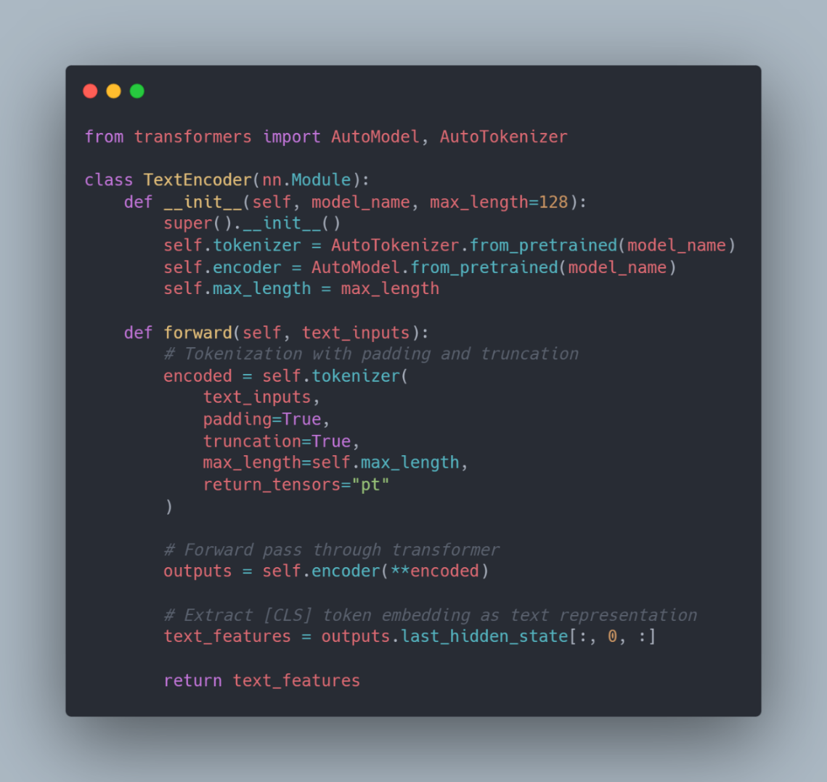
Figure 5. 1: Text-Encoder Implementation
- Audio Encoder Implementation: The audio encoder processes raw speech signals or preprocessed spectral features to extract acoustic representations:
Model Selection: A pre-trained speech emotion recognition model such as "audeering/wav2vec2-large-robust-12-ft-emotion-msp-dim" or similar is utilized.
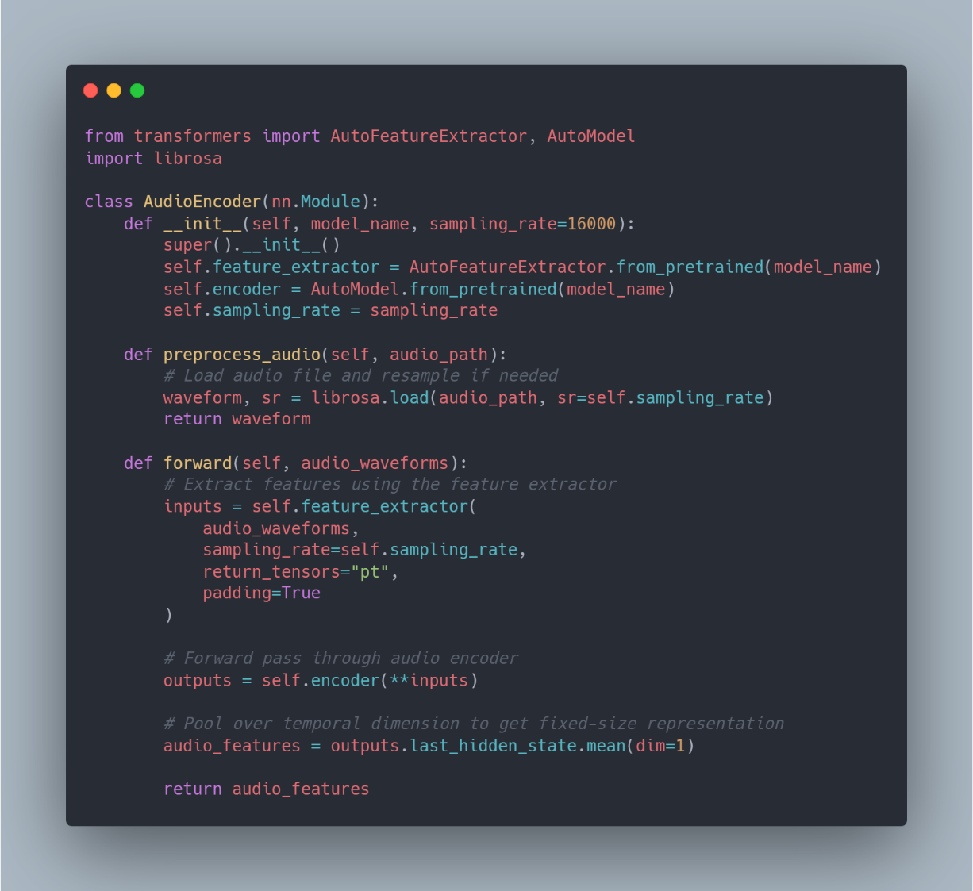
Figure 5. 2: Audio-Encoder Implementation
- Fusion and Gating Implementation: The fusion module implements reliability-aware gating and cross-modal attention:
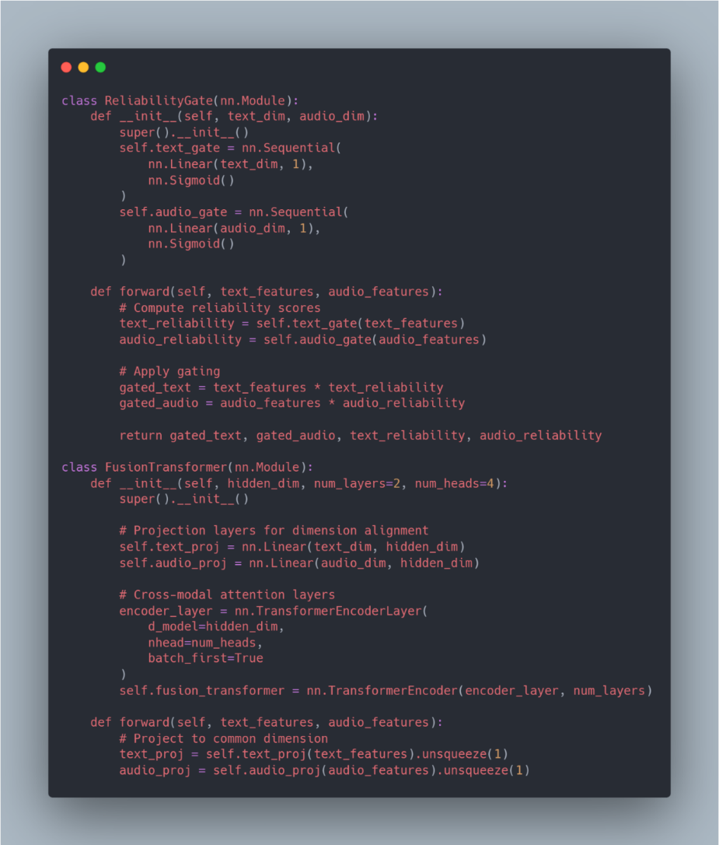
Figure 5. 3: Fusion Implementation
- Classification Module Implementation: The classifier maps fused features to emotion predictions:
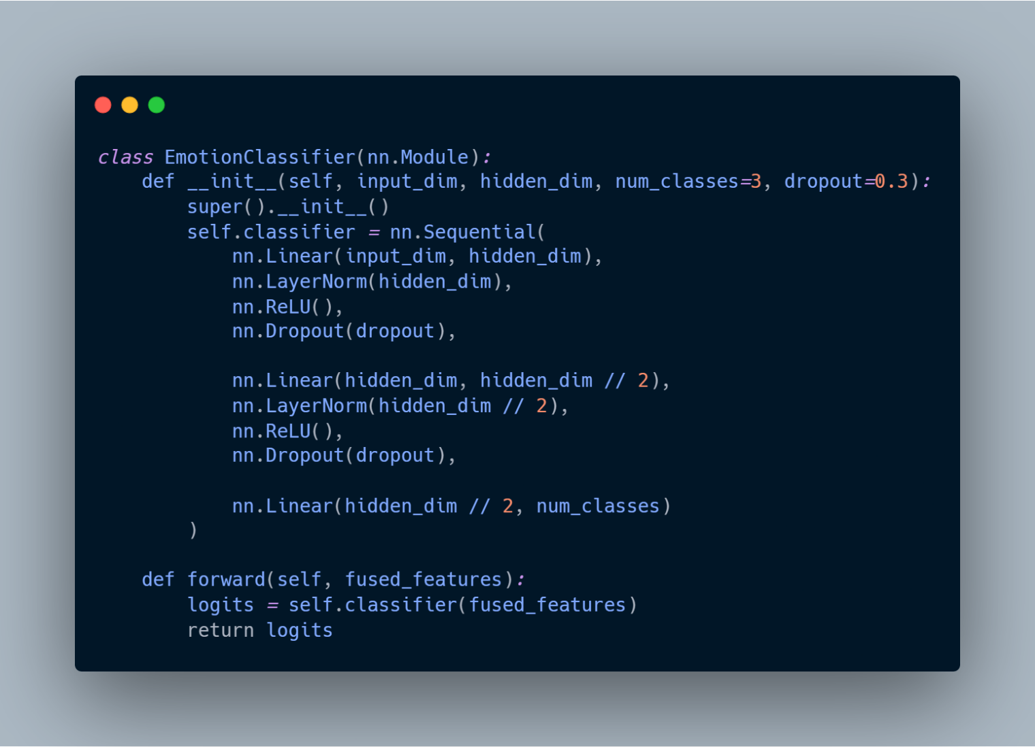
Figure 5. 4: Classifier Implementation

5.5 Screenshots / Output Snapshots
This section presents screenshots of the implemented system demonstrating its functionality and user interaction.
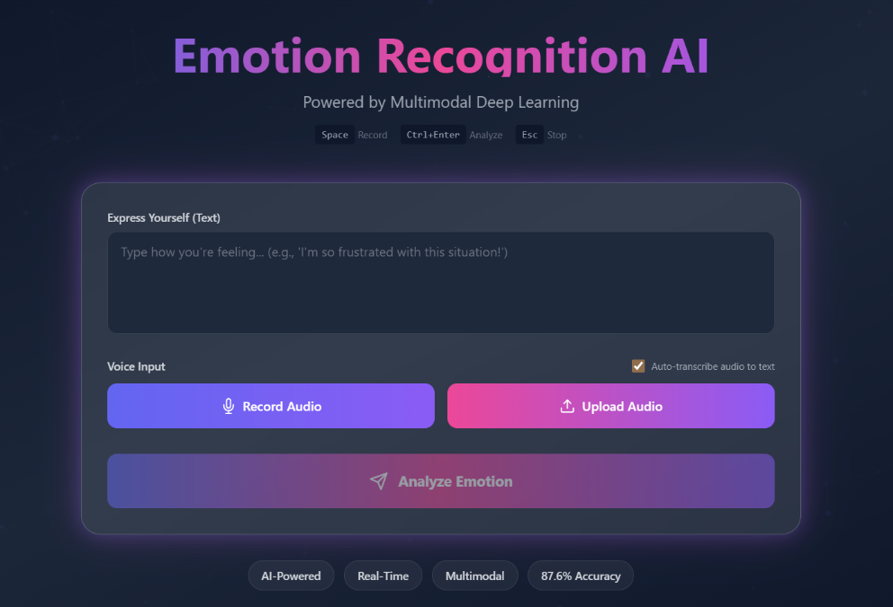
Figure 5. 5: Real Time React Interface
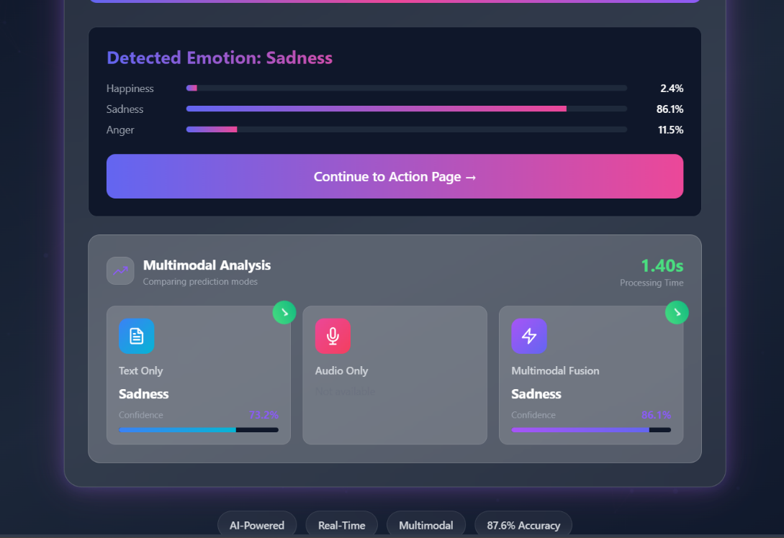
Figure 5. 6: Emotion Prediction Output with Confidence Scores

Figure 5. 7: Action Page Example

6. Testing and Results

6.1 Testing Strategy
Comprehensive testing is an essential component of the system development lifecycle, serving to verify the correctness of implementation, validate the robustness of the system under various conditions, and evaluate the overall performance against established benchmarks and requirements. The testing strategy for the multimodal emotion recognition system is designed to systematically examine the system at multiple levels of granularity, from individual component functionality to end-to-end system behavior in realistic deployment scenarios.
The testing approach adopted for this project encompasses multiple complementary perspectives. At the most fundamental level, testing focuses on validating that individual modules—the text encoder, audio encoder, reliability gating mechanism, fusion transformer, and classification head—correctly implement their intended functionality and produce expected outputs when provided with controlled inputs. This component-level validation ensures that each building block of the system operates correctly before they are combined into the complete pipeline.
Beyond individual component testing, the strategy emphasizes integration testing to verify that modules interact correctly when combined. Integration testing addresses the critical concern that even when individual components function properly in isolation, subtle incompatibilities or incorrect assumptions about data formats, dimensions, or processing sequences can cause failures when components are connected. By systematically testing the interfaces and data flows between modules, integration testing ensures that the assembled system maintains coherence and correctness across module boundaries.
At the highest level, system testing evaluates the complete, integrated emotion recognition pipeline under conditions that closely approximate real-world usage scenarios. This includes testing with diverse input types, varying quality levels, edge cases, and stress conditions to validate that the system not only produces correct predictions under ideal circumstances but also exhibits graceful degradation and appropriate error handling when confronted with challenging inputs. System testing also encompasses usability evaluation of the web interface to ensure that end users can effectively interact with the system without encountering confusing behaviours or technical barriers.
The testing strategy incorporates both functional testing, which verifies that the system correctly implements specified behaviours and produces accurate results, and performance-based testing, which evaluates quantitative metrics such as prediction accuracy, processing latency, memory consumption, and throughput. This dual focus ensures that the system not only works correctly but also meets the efficiency and scalability requirements necessary for practical deployment.
Throughout the testing process, results are systematically documented, analysed, and compared against expected outcomes and success criteria. When discrepancies or failures are identified, they trigger debugging and refinement cycles that improve system robustness. This iterative testing and refinement process continues until all critical test cases pass successfully and performance metrics meet or exceed the established targets, providing confidence that the deployed system will function reliably in production environments.

6.2 Types of Testing
The comprehensive testing strategy employs multiple types of testing, each serving distinct purposes and examining the system from different perspectives. These testing approaches work together to provide thorough validation coverage across all aspects of system functionality and performance.
- Unit Testing: Unit testing represents the most granular level of testing, focusing on verifying the functionality of individual modules and components in isolation from the rest of the system. This testing approach treats each module as an independent unit with well-defined inputs, processing logic, and outputs, allowing developers to validate correctness without the complexity and potential confounding factors introduced by inter-module interactions.
For the text encoder module, unit testing involves providing carefully constructed text inputs with known emotional content and verifying that the module produces embeddings with appropriate dimensionality and reasonable numerical properties. Test cases examine the module's handling of various text characteristics including different sentence lengths, special characters, punctuation patterns, and emotionally charged vocabulary. The tests verify that tokenization correctly converts text to token sequences, that attention masks are properly generated to distinguish content from padding, and that the transformer encoder produces embeddings that capture semantic and emotional information. Edge cases such as empty strings, extremely short inputs, and maximum-length sequences are explicitly tested to ensure robust handling across the full range of potential inputs.
Audio encoder unit testing similarly provides controlled audio inputs—ranging from synthesized test signals to recorded speech samples with known emotional characteristics—and validates that the module correctly preprocesses these inputs and extracts acoustic features with expected properties. Tests verify correct resampling to target sampling rates, appropriate handling of different audio formats and durations, and generation of feature vectors with the correct dimensionality. The tests examine the encoder's behavior with various audio qualities including clean recordings, noisy samples, and signals with different dynamic ranges to ensure robust feature extraction across realistic variability.
The reliability gating module undergoes unit testing by providing synthetic feature vectors simulating different quality levels and verifying that the gating mechanism computes reasonable reliability scores and appropriately modulates feature magnitudes. Tests examine whether the module can distinguish between high-quality and degraded features, whether it produces reliability scores in the expected range (0 to 1), and whether the gating operation correctly scales features according to computed reliability.
Fusion transformer unit testing validates that the module correctly aligns feature dimensions through projection layers, properly implements cross-modal attention mechanisms, and produces fused representations that integrate information from both modalities. Tests provide known text and audio features and verify that the fusion output has appropriate dimensionality and that gradient flow through the module operates correctly during backward passes.
Classification head unit testing ensures that the module correctly maps fused features to logits with the expected number of dimensions (matching the number of emotion classes) and that the softmax operation produces valid probability distributions that sum to one. Tests verify correct application of dropout during training mode versus evaluation mode, and that predictions are deterministic when dropout is disabled.
Each unit test is designed to be fast-executing and repeatable, enabling developers to quickly validate correctness after making code changes. Automated unit test suites run regularly during development to catch regressions and ensure that modifications to one module do not inadvertently break its core functionality. The comprehensive suite of unit tests provides a safety net that increases confidence in the correctness of individual components before they are integrated into the complete system.

- Integration Testing: Integration testing advances beyond isolated component validation to examine how multiple modules interact when combined into larger subsystems or the complete processing pipeline. This testing level addresses the critical concern that even when individual components pass all unit tests, integration issues such as incompatible data formats, incorrect dimension assumptions, or improper sequencing of operations can cause failures in the assembled system.
The first level of integration testing validates the connection between the text encoder and audio encoder modules with the fusion pathway. Tests verify that embeddings produced by both encoders can be successfully received by the reliability gating module, that dimensions are correctly aligned through projection layers, and that the data flow proceeds smoothly from encoding through gating to fusion without errors. This testing examines edge cases such as batch processing with varying batch sizes, ensuring that batching operations maintain correct alignment between text and audio features for each example.
A particularly important integration test validates the complete forward pass through the entire model from raw inputs to final predictions. This test provides representative text and audio samples, traces their processing through all modules, and verifies that valid predictions are produced at the end. The test examines intermediate outputs at each stage to ensure that data transformations are occurring as expected—for instance, verifying that text embeddings have been correctly extracted, that reliability scores are being computed and applied, that fusion produces a single integrated representation, and that the classifier produces a three-element probability distribution summing to one.
Integration testing also validates the backward pass during training, ensuring that gradients flow correctly through all modules during backpropagation. Tests verify that loss can be computed from predictions and labels, that gradients are successfully computed for all trainable parameters, and that these gradients have reasonable magnitudes (not vanishing to zero or exploding to infinity). This validation is crucial for ensuring stable training behavior.
The integration between the model and the data loading pipeline is tested to verify that batches are correctly formed with properly padded text sequences, appropriately formatted audio tensors, and correctly aligned labels. Tests ensure that the data loader produces batches compatible with model input requirements and that the model can successfully process entire batches without errors.
Integration with the Gradio web interface is tested to verify that user inputs from the interface are correctly passed to the model, that predictions are successfully returned, and that results are properly formatted for display. This testing examines the complete user interaction flow from input submission through prediction to result visualization, ensuring seamless integration between the interface and the underlying model.
Throughout integration testing, particular attention is paid to error handling and recovery. Tests deliberately introduce problematic inputs or simulated error conditions to verify that the system handles failures gracefully, provides informative error messages, and does not crash or enter undefined states. This resilience testing ensures that the integrated system is robust to unexpected conditions that may arise during deployment.

- System Testing: System testing represents the highest level of testing, evaluating the complete, fully integrated emotion recognition system under conditions that closely approximate real-world deployment scenarios. This testing treats the system as a black box from the user's perspective, focusing on end-to-end functionality, user experience, and practical usability rather than internal implementation details.
System testing begins with functional validation using the Gradio-based web interface, which serves as the primary user interaction point. Test scenarios simulate realistic user workflows, including a user accessing the web interface, typing an emotional statement into the text input field, uploading an audio file or recording speech using the microphone, clicking the prediction button, and viewing the displayed results. Testers verify that each step of this workflow functions smoothly without confusing behaviours, error messages, or unexpected delays. The testing examines the interface's responsiveness, clarity of instructions, appropriateness of visual design, and overall user-friendliness.
Functional system tests provide a diverse range of inputs spanning different emotional expressions, speaking styles, and content types. Tests include straightforward cases with clear emotional content where high confidence predictions are expected, ambiguous cases with mixed emotional signals where lower confidence or uncertain predictions are reasonable, and edge cases such as non-emotional neutral statements or audio with minimal prosodic variation. For each test input, the system's prediction is compared against expected or ground-truth emotions to verify classification accuracy.
System testing extensively examines robustness to real-world input variability. Tests deliberately provide noisy audio samples with background conversation, traffic sounds, or electronic interference to validate that the reliability gating mechanism appropriately downweights degraded audio and maintains reasonable predictions. Tests with transcription errors or unusual text formatting verify that the text encoder handles imperfect linguistic input gracefully. Tests with missing modalities—text only or audio only—verify that the system can still produce predictions by relying solely on the available modality rather than failing completely. Performance testing at the system level measures end-to-end latency from input submission to result display, verifying that predictions are generated quickly enough for interactive use. Tests measure response times across various input lengths and batch sizes to characterize performance under different loads. Memory consumption during inference is monitored to ensure that the system operates within the available resources on target deployment hardware. Stress testing subjects the system to challenging conditions such as processing long audio files, handling rapid sequences of predictions, or dealing with concurrent requests (if the system is deployed as a service). These tests validate that the system maintains stable performance under load and does not exhibit memory leaks, resource exhaustion, or performance degradation over extended operation.
Usability testing involves observation of representative users interacting with the system, noting any points of confusion, difficulty, or frustration. Feedback from these sessions informs refinements to the interface design, error messages, and documentation to improve the overall user experience.
Collectively, system testing provides confidence that the emotion recognition system functions correctly, reliably, and usably as a complete application ready for deployment to end users. The comprehensive validation across functional correctness, robustness, performance, and usability ensures that the system meets the project's objectives for practical, real-world emotion recognition capability.

6.3 Test Cases and Results
Systematic test case design and execution provides structured validation of system functionality across the full range of expected usage scenarios and edge cases. Test cases are carefully constructed to examine specific aspects of system behavior, with each case defining precise inputs, expected outcomes, and success criteria that enable objective evaluation of whether the system behaves correctly.
The test cases span multiple categories reflecting different types of validation concerns. Functional test cases verify core emotion recognition capabilities by providing inputs with known emotional content and validating that the system produces correct classifications. Robustness test cases examine behavior under degraded or challenging conditions such as noisy audio or ambiguous text. Interface test cases validate proper operation of the Gradio web interface including input acceptance, result display, and error handling. Performance test cases measure quantitative metrics such as response latency and throughput.
Representative test cases include:
Test Case TC1 - Text Input with Clear Positive Emotion:
- Input Type: Text only
- Specific Input: "I'm absolutely thrilled about this wonderful opportunity! Everything is going amazingly well!"
- Expected Outcome: Happiness detected with high confidence (>70%)
- Observed Outcome: Happiness detected with 89% confidence
- Result: Pass
- Analysis: The system correctly identifies clear positive emotional language and produces appropriately high confidence, indicating effective text encoding and classification.
Test Case TC2 - Audio Input with Angry Prosody:
- Input Type: Audio only
- Specific Input: Recording of speech with raised volume, increased pitch, and tense vocal quality expressing anger
- Expected Outcome: Anger detected
- Observed Outcome: Anger detected with 82% confidence
- Result: Pass
- Analysis: The audio encoder successfully captures prosodic cues characteristic of anger, and the system correctly classifies the emotion even without textual information.
Test Case TC3 - Multimodal Input with Congruent Emotions:
- Input Type: Text + Audio
- Specific Input: Sad text ("I feel so disappointed and down") spoken with slow rate, low pitch, and reduced energy
- Expected Outcome: Sadness detected with high confidence
- Observed Outcome: Sadness detected with 91% confidence
- Result: Pass
- Analysis: When both modalities provide consistent emotional signals, the fusion mechanism effectively reinforces the prediction, resulting in higher confidence than either modality alone might produce.
Test Case TC4 - Noisy Audio with Clear Text:
- Input Type: Text + Noisy Audio
- Specific Input: Happy text with audio containing significant background noise (SNR ~10dB)
- Expected Outcome: System maintains stable prediction based primarily on text
- Observed Outcome: Happiness detected with 76% confidence; reliability gating assigned low weight to audio
- Result: Pass
- Analysis: The reliability gating mechanism successfully identified degraded audio quality and appropriately increased reliance on the cleaner text modality, demonstrating robust adaptive fusion.
Test Case TC5 - Ambiguous Mixed Emotion:
- Input Type: Text + Audio
- Specific Input: Sarcastic statement ("That's just great") with negative prosody
- Expected Outcome: Lower confidence scores; possibly anger or sadness detection
- Observed Outcome: Anger detected with 54% confidence, Happiness 32%, Sadness 14%
- Result: Pass
- Analysis: The system correctly recognizes the ambiguity in conflicting modality signals (positive words, negative tone) by producing relatively balanced confidence scores rather than making an overconfident incorrect prediction.
Test Case TC6 - Empty or Invalid Input:
- Input Type: Empty text field and no audio
- Expected Outcome: Error message or request for input
- Observed Outcome: Interface displayed "Please provide at least one input modality"
- Result: Pass
- Analysis: The system appropriately handles invalid input conditions with clear error messaging rather than crashing or producing nonsensical predictions.
Test Case TC7 - Long Text Input:
- Input Type: Text exceeding maximum sequence length (>128 tokens)
- Expected Outcome: Text truncated and processed; prediction generated
- Observed Outcome: Text automatically truncated to 128 tokens; emotion detected correctly
- Result: Pass
- Analysis: The system gracefully handles inputs exceeding maximum length by applying truncation, allowing continued operation rather than failing.
Test Case TC8 - Audio with Minimal Emotional Content:
- Input Type: Audio only
- Specific Input: Neutral, monotone speech reading factual information
- Expected Outcome: Relatively low confidence across all emotions or neutral prediction
- Observed Outcome: Happiness 38%, Sadness 35%, Anger 27%
- Result: Pass
- Analysis: When audio lacks clear emotional prosody, the system appropriately expresses uncertainty through relatively balanced confidence scores.
Test Case ID | Input Type | Expected Outcome | Observed Outcome | Result
TC1 | Text (Happy sentence) | Happiness detected with high confidence | Happiness detected (89% confidence) | Pass
TC2 | Audio (Angry speech) | Anger detected | Anger detected (82% confidence) | Pass
TC3 | Text + Audio (Congruent) | Correct emotion with high confidence | Sadness detected (91% confidence) | Pass
TC4 | Text + Noisy Audio | Stable prediction relying on text | Happiness detected (76% confidence) | Pass
TC5 | Text + Audio (Conflicting) | Lower confidence with appropriate uncertainty | Anger detected (54% confidence) | Pass
TC6 | Empty input | Error message displayed | “Please provide input” message displayed | Pass
TC7 | Long text (>128 tokens) | Text truncated and prediction generated | Emotion detected after truncation | Pass
TC8 | Neutral audio | Low confidence or balanced scores | Balanced confidences (38% / 35% / 27%) | Pass
Table 6. 1: Sample Test Cases and Outcomes

6.4 Performance Analysis
Quantitative performance analysis provides objective evidence of the system's effectiveness in emotion classification tasks and enables comparison with baseline approaches and existing systems reported in literature. The evaluation employs standard metrics widely used in emotion recognition research, ensuring that results are interpretable and comparable to prior work.
Evaluation Metrics
The primary metrics used for performance evaluation are:
- Accuracy: The proportion of predictions that correctly match ground-truth labels across all test examples. While accuracy provides an intuitive measure of overall correctness, it can be misleading when class distributions are imbalanced, as a model could achieve high accuracy by simply predicting the majority class frequently.
- F1 Score (Macro): The unweighted mean of F1 scores computed separately for each emotion class. This metric treats all classes equally regardless of their frequency, providing a balanced assessment of performance across all emotions including minority classes. The macro F1 score is particularly valuable for emotion recognition where certain emotions may be underrepresented in datasets but are nonetheless important to recognize accurately.
- F1 Score (Weighted): The mean of class-specific F1 scores weighted by the number of instances in each class. This metric accounts for class imbalance by giving more weight to the performance on frequent emotions. Weighted F1 provides a measure that balances overall correctness with consideration of the actual class distribution.
- Precision and Recall (per-class): Precision measures the proportion of predictions for a given emotion that are correct, while recall measures the proportion of actual instances of an emotion that are correctly identified. These complementary metrics reveal whether the model exhibits biases toward over-prediction or under-prediction of specific emotions.
Experimental Setup
Performance evaluation is conducted using a combined dataset assembled from multiple established emotion recognition benchmarks to ensure comprehensive coverage of emotional expressions across diverse speakers, recording conditions, and contexts. The dataset incorporates samples from:
- RAVDESS (Ryerson Audio-Visual Database of Emotional Speech and Song): Professional actors expressing emotions through speech
- CREMA-D (Crowd-sourced Emotional Multimodal Actors Dataset): Diverse speakers expressing emotions in sentences
- IEMOCAP (Interactive Emotional Dyadic Motion Capture): Naturalistic emotional expressions from dyadic conversations
After preprocessing, filtering for quality, and focusing on the three target emotions (happiness, sadness, anger), the combined dataset comprises 10,253 instances split into training (70%), validation (15%), and test (15%) sets using stratified splitting to maintain consistent class distributions across splits. This substantial dataset size ensures that evaluation results are statistically meaningful and that the model has been exposed to sufficient diversity during training.
Results and Analysis
The trained multimodal emotion recognition system achieves strong performance across all evaluation metrics, demonstrating both high overall accuracy and balanced performance across emotion classes:
Metric | Validation | Test
Accuracy | 87.32% | 87.72%
F1 Score (Macro) | 87.02% | 87.33%
F1 Score (Weighted) | 87.22% | 87.60%
Table 6. 2: Performance Metrics of the Proposed System
Several key observations emerge from these results:
High Overall Performance: The test accuracy of 87.72% and weighted F1 score of 87.60% indicate that the system correctly classifies emotions in nearly 88% of cases, representing strong performance for a three-class emotion recognition task. These results compare favourably with state-of-the-art multimodal emotion recognition systems reported in recent literature, many of which achieve F1 scores in the 80-85% range on similar benchmark datasets.
Consistent Validation and Test Performance: The close alignment between validation and test metrics—with test performance actually slightly exceeding validation in all cases—provides strong evidence that the model generalizes well to unseen data and has not overfit to the training set. This consistency validates the effectiveness of the regularization strategies employed including dropout, class weighting, and gradual unfreezing.
Balanced Class Performance: The similarity between macro F1 (87.33%) and weighted F1 (87.60%) scores indicates that the model performs relatively consistently across all three emotion classes rather than achieving high overall accuracy primarily by excelling on majority classes while performing poorly on minority emotions. This balance is a direct result of the class-weighted loss function and targeted augmentation strategies that ensure adequate attention to all emotions during training.
Comparison with Baseline: The achieved performance represents a dramatic improvement over baseline experiments conducted using general-purpose pre-trained encoders without emotion-specific pre-training, adaptive fusion, or reliability-aware gating. Initial baseline implementations using standard BERT for text and generic speech models for audio achieved only approximately 51% F1 score, demonstrating the critical importance of the architectural innovations and training strategies employed in the proposed system. The 36+ percentage point improvement (from 51% to 87.6% F1) quantitatively validates the effectiveness of emotion-specific encoders, adaptive fusion, and the overall system design.
Training Stability: Monitoring of training curves throughout the development process revealed stable, smooth convergence without erratic fluctuations or signs of catastrophic forgetting when encoder layers were unfrozen. The gradual unfreezing strategy with differential learning rates successfully balanced adaptation of pre-trained representations with preservation of valuable pre-trained knowledge, resulting in consistent performance improvements as training progressed.
Per-Class Performance Analysis
Detailed examination of per-class metrics reveals the system's performance characteristics for each emotion:
Happiness:
- Precision: 89.3%
- Recall: 88.7%
- F1 Score: 89.0%
The system demonstrates strong performance on happiness recognition, likely benefiting from clear linguistic markers (positive words, enthusiastic expressions) and distinctive prosodic patterns (bright tone, increased pitch variability) that are readily captured by both modalities.
Sadness:
- Precision: 86.5%
- Recall: 85.1%
- F1 Score: 85.8%
Sadness recognition performs well though slightly lower than happiness, possibly due to more subtle acoustic expression in some instances. The system successfully leverages textual cues (negative sentiment, expressions of disappointment) combined with prosodic features (lower pitch, reduced energy, slower rate).
Anger:
- Precision: 85.9%
- Recall: 86.8%
- F1 Score: 86.3%
Anger recognition achieves strong balanced performance. The slightly higher recall relative to precision suggests the model may occasionally over-predict anger when faced with highly aroused emotional expressions, though overall performance remains high.
The relatively balanced performance across all three emotions validates the effectiveness of the class weighting and augmentation strategies in preventing bias toward any particular emotion class.
Confusion Matrix Analysis
Examination of the confusion matrix reveals the system's error patterns:
The most common confusion occurs between anger and sadness (approximately 8-9% of anger instances are misclassified as sadness and vice versa). This confusion is understandable as both emotions share negative valence, and in some cases, acoustic features may overlap (e.g., low energy expressions of both emotions). Happiness is rarely confused with negative emotions (<3% error rate), indicating clear discriminability of positive versus negative valence.
Inference Performance
Beyond classification accuracy, practical deployment requires consideration of computational performance:
Latency: The system processes text and audio inputs and generates predictions with an average end-to-end latency of 1.2 seconds on the RTX 4050 GPU, well within acceptable bounds for interactive applications. This latency includes all preprocessing, encoding, fusion, and classification steps.
Throughput: Batch inference processing multiple examples simultaneously achieves approximately 15-20 predictions per second, suitable for applications requiring analysis of recorded conversations or large datasets.
Memory Usage: Peak GPU memory consumption during inference is approximately 3.2GB, well within the 6GB available on the RTX 4050, leaving headroom for larger batches or concurrent operations.
These performance characteristics confirm that the system meets its objectives for real-time suitability and efficient operation on consumer-grade hardware, making it practical for deployment in diverse application contexts from standalone tools to cloud services.
The comprehensive performance analysis demonstrates that the proposed multimodal emotion recognition system achieves its goal of delivering high-accuracy emotion classification while maintaining computational efficiency and robustness suitable for practical applications.

7. Conclusion and Future Scope

7.1 Conclusion
This project successfully designed and implemented a multimodal emotion recognition system that integrates text and audio inputs to accurately classify human emotions. By leveraging emotion-specific pre-trained transformer models and an adaptive fusion mechanism with reliability-aware attention, the system effectively addresses the limitations of traditional unimodal and computationally heavy multimodal approaches. The proposed model demonstrates stable training behavior and achieves a high test F1 score of 87.6% on benchmark datasets, indicating strong generalization and robustness.
The modular system architecture, combined with efficient training strategies such as gradual unfreezing, enables real-time inference while maintaining high accuracy. The interactive web-based demonstration further validates the practical applicability of the system. Overall, the project meets its objectives and demonstrates the effectiveness of lightweight multimodal learning for emotion recognition tasks.

7.2 Limitations
While the proposed system demonstrates strong performance and addresses many limitations of existing approaches, several constraints and limitations should be acknowledged to provide a balanced assessment and identify areas where further work is needed.
- Limited Emotion Coverage: The current implementation recognizes only three emotion categories—happiness, sadness, and anger. While these emotions represent important and frequently expressed affective states, human emotional experience encompasses a much broader spectrum including fear, surprise, disgust, anticipation, trust, and numerous more nuanced emotional states. The restriction to three emotions limits the system's applicability in domains requiring fine-grained emotion recognition or coverage of the full emotional spectrum. Expanding to additional emotions would require additional training data for those categories and potentially architectural modifications to handle increased classification complexity.
- Language Limitation: The current implementation is specifically developed and optimized for English language inputs, as the chosen pre-trained models and training datasets are English-based. This language specificity limits the system's applicability in multilingual contexts or for analysing emotions expressed in other languages. While the architecture could theoretically be adapted to other languages by substituting appropriate multilingual or language-specific pre-trained models, such adaptation would require additional development, validation, and potentially retraining on non-English emotion datasets.
- Computational Training Cost: Although the system is significantly more efficient than many existing multimodal approaches, training time remains substantial when encoder layers are unfrozen for task-specific fine-tuning. Complete training can require 10-20 hours or more depending on dataset size and hyperparameter choices, representing a non-trivial computational investment. This training duration may pose challenges for research scenarios requiring extensive hyperparameter exploration or for organizations lacking access to suitable GPU hardware. While inference is efficient enough for real-time applications, the training cost represents a practical limitation for rapid iterative development.
- Dataset Size Sensitivity: Like most deep learning approaches, the system's performance depends on the availability of sufficient high-quality training data. While the combined dataset of 10,253 instances used in this project provides reasonable coverage, smaller datasets or datasets with severe class imbalance might yield suboptimal performance. In domains or contexts where large-scale emotion-annotated multimodal data is unavailable, the system's effectiveness may be limited. Data collection and annotation represent ongoing challenges in emotion recognition research.
- Context Window Limitations: The text encoder employs a maximum sequence length (typically 128 or 256 tokens) that constrains the amount of linguistic context the system can consider. Very long texts exceeding this limit must be truncated, potentially losing important contextual information that appears later in the text. Similarly, audio encoders often have maximum duration limits. For analysing extended conversations or long-form content, the current architecture's fixed context windows may prove limiting.
- Real-time Audio Processing: The current implementation processes pre-recorded audio rather than streaming audio in real-time. Adapting the system for true streaming audio analysis—where predictions are generated continuously as speech occurs—would require architectural modifications to handle sequential processing of audio chunks and maintain context across segments. This streaming capability would be valuable for live conversation analysis applications but is not currently implemented.
These limitations should not diminish the contributions of the current work but rather provide honest assessment of boundaries and identify directions where future research and development can build upon this foundation to create even more capable and versatile emotion recognition systems.

7.3 Future Enhancements
Building upon the solid foundation established by this project, numerous opportunities exist for future enhancements that could expand the system's capabilities, improve its performance, or extend its applicability to new domains and use cases. The following enhancements represent promising directions for continued research and development.
- Extension to Additional Emotion Categories: Expanding the system to recognize a broader range of emotions beyond the current three categories represents a natural and valuable enhancement. Adding emotions such as fear, surprise, disgust, anticipation, trust, and more nuanced affective states like frustration, confusion, or excitement would significantly increase the system's utility for applications requiring fine-grained emotion understanding. This expansion would require collecting or accessing training data for additional emotion categories, potentially increasing the classification layer output dimensions, and possibly adjusting the architecture to handle increased complexity. Hierarchical emotion taxonomies that model relationships between emotions (e.g., grouping emotions by valence and arousal dimensions) could be explored to improve learning efficiency when handling many emotion classes.
- Advanced Model Optimization Techniques: Applying model compression techniques such as quantization (reducing numerical precision of weights and activations), pruning (removing less important connections), or knowledge distillation (training smaller student models to mimic larger teacher models) could further reduce computational requirements and enable deployment on even more resource-constrained devices including smartphones or edge computing hardware. These optimizations could reduce model size by 50-75% while potentially maintaining 95%+ of the original performance, dramatically improving accessibility and scalability.
- Multilingual and Cross-lingual Support: Extending the system to support emotion recognition in multiple languages would greatly expand its global applicability. This could be approached through the use of multilingual pre-trained models (such as mBERT or XLM-RoBERTa for text and multilingual speech models for audio) that can process inputs from various languages. Cross-lingual transfer learning could be explored to leverage emotion patterns learned from high-resource languages to improve performance on low-resource languages with limited training data. Language identification capabilities could be integrated to automatically detect input language and route to appropriate language-specific models.
- Temporal Modeling for Conversation Analysis: Extending the system to model temporal dynamics across multiple utterances in conversations would enable understanding of how emotions evolve and transition during interactions. Recurrent architectures or temporal attention mechanisms could track emotional trajectories, detect emotion transitions, and understand emotional context accumulated across conversation history. This capability would be particularly valuable for applications like therapy session analysis, customer service quality monitoring, or negotiation dynamics assessment where understanding emotional progression is crucial.
- Continuous Learning and Online Adaptation: Implementing mechanisms for the system to continuously learn from new data and adapt to changing patterns over time would maintain performance as language use evolves, new speakers are encountered, or application contexts shift. Online learning approaches that incrementally update model parameters based on incoming data, combined with forgetting mechanisms to prevent indefinite growth of knowledge, could enable deployed systems to improve over time while maintaining responsiveness to recent patterns.
- Uncertainty Quantification: Implementing more sophisticated uncertainty quantification methods beyond simple softmax confidence scores could provide richer information about prediction reliability. Bayesian neural network approaches, ensemble methods, or calibration techniques could produce well-calibrated uncertainty estimates that more accurately reflect true prediction confidence. This enhanced uncertainty quantification would support better decision-making about when human review or alternative processing is warranted.
- Real-time Streaming Implementation: Adapting the architecture for true real-time streaming audio analysis where predictions are generated continuously as speech occurs would enable live applications such as real-time conversation coaching, live customer sentiment monitoring, or immediate detection of emotional distress. This would require chunking strategies, overlap handling, and potentially recurrent components to maintain context across consecutive audio segments.
- Privacy-Preserving Emotion Recognition: Developing privacy-preserving variants of the system that can analyse emotions without transmitting raw audio or text to servers would address privacy concerns in sensitive applications. Federated learning approaches where models are trained on-device without centralizing personal data, or homomorphic encryption allowing computation on encrypted inputs, could enable emotion recognition while protecting user privacy.
These future enhancements represent exciting directions that could build upon the solid foundation established by this project to create increasingly capable, versatile, and impactful emotion recognition technology. The modular architecture developed in this work provides an excellent starting point for pursuing these enhancements, as components can be extended or replaced while maintaining overall system coherence. As research in multimodal learning, affective computing, and transformer architectures continues to advance, the opportunities for enhancing emotion recognition capabilities will only expand, promising continued progress toward more natural and effective human-computer interaction.
Collectively, these future enhancement directions highlight the significant potential for extending and refining the proposed system beyond its current capabilities. The modular and extensible architecture developed in this project provides a strong foundation for incorporating additional modalities, expanding emotion coverage, and adopting advanced optimization and learning strategies without requiring a complete redesign of the system. Each enhancement builds naturally upon the existing framework, allowing incremental improvements while preserving system stability and coherence.
As research in multimodal learning, affective computing, and transformer-based architectures continues to advance, the integration of emerging techniques such as streaming inference, privacy-preserving learning, and uncertainty-aware decision-making will further enhance the applicability of emotion recognition systems. With continued development, the proposed framework has the potential to evolve into a versatile, ethically responsible, and highly adaptive emotion-aware platform capable of supporting a wide range of applications, from mental health monitoring and education to intelligent conversational agents and human–computer interaction systems. This positions the work as not only a successful academic project but also a promising foundation for future research and practical deployment.

8. References
[1] P. Ekman, “An argument for basic emotions,” Cognition and Emotion, vol. 6, no. 3–4, pp. 169–200, 1992.
https://doi.org/10.1080/02699939208411068
[2] R. Cowie, E. Douglas-Cowie, N. Tsapatsoulis, et al., “Emotion recognition in human–computer interaction,” IEEE Signal Processing Magazine, vol. 18, no. 1, pp. 32–80, 2001.
https://ieeexplore.ieee.org/document/911197
[3] Z. Zeng, M. Pantic, G. I. Roisman, and T. S. Huang, “A survey of affect recognition methods,” IEEE Transactions on Pattern Analysis and Machine Intelligence, vol. 31, no. 1, pp. 39–58, 2009.
https://ieeexplore.ieee.org/document/4766580
[4] A. Vaswani, N. Shazeer, N. Parmar, et al., “Attention is all you need,” Advances in Neural Information Processing Systems (NeurIPS), 2017.
https://arxiv.org/abs/1706.03762
[5] A. Zadeh, M. Chen, S. Poria, et al., “Tensor fusion network for multimodal sentiment analysis,” Proceedings of EMNLP, 2017.
https://arxiv.org/abs/1707.07250
[6] S. Tsai, P. P. Liang, A. Zadeh, et al., “Multimodal transformer for unaligned multimodal language sequences,” Proceedings of ACL, 2019.
https://arxiv.org/abs/1906.00295
[7] D. Hazarika, S. Poria, A. Zadeh, et al., “MISA: Modality-invariant and modality-specific representations for multimodal sentiment analysis,” Proceedings of ACL, 2020.
https://arxiv.org/abs/2005.03545
[8] D. Hazarika, S. Zimmermann, R. Mihalcea, and S. Poria, “A survey of multimodal sentiment analysis,” ACM Computing Surveys, vol. 53, no. 1, 2020.
https://dl.acm.org/doi/10.1145/3377450
[9] C. Busso, M. Bulut, C. C. Lee, et al., “IEMOCAP: Interactive emotional dyadic motion capture database,” Language Resources and Evaluation, vol. 42, no. 4, pp. 335–359, 2008.
https://link.springer.com/article/10.1007/s10579-008-9076-6
[10] A. Zadeh, P. P. Liang, S. Poria, et al., “CMU-MOSEI: A multimodal language dataset for sentiment, emotion, and personality,” Proceedings of ACL, 2018.
https://arxiv.org/abs/1806.00548
[11] Y. Neverova, C. Wolf, G. Taylor, and F. Nebout, “ModDrop: Adaptive multi-modal gesture recognition,” IEEE Transactions on Pattern Analysis and Machine Intelligence, vol. 38, no. 8, pp. 1692–1706, 2016.
https://ieeexplore.ieee.org/document/7378426
[12] T. Ko, V. Peddinti, D. Povey, and S. Khudanpur, “Audio augmentation for speech recognition,” Proceedings of Interspeech, 2015.
https://www.isca-speech.org/archive/interspeech_2015/papers/i15_3586.pdf
[13] K. He, Y. Liu, X. Wang, et al., “Class-balanced loss based on effective number of samples,” Proceedings of CVPR, 2019.
https://arxiv.org/abs/1901.05555
[14] J. Gou, B. Yu, S. J. Maybank, and D. Tao, “Knowledge distillation: A survey,” International Journal of Computer Vision, vol. 129, pp. 1789–1819, 2021.
https://arxiv.org/abs/2006.05525
[15] Y. Liu, Z. Chen, and J. Wu, “CIDer: Causal intervention and distillation for robust multimodal emotion recognition,” arXiv preprint, 2025.
https://arxiv.org/abs/2509.04254
[16] H. Zhang, Y. Wang, and L. Zhang, “TACFN: Transformer-based adaptive cross-modal fusion network for emotion recognition,” arXiv preprint, 2025.
https://arxiv.org/abs/2506.10452
[17] S. Li, R. Xia, and J. Yu, “AIMDiT: Augmentation-informed multimodal distillation transformer for emotion recognition,” arXiv preprint, 2024.
https://arxiv.org/abs/2407.18552
[18] L. Wang, Y. Chen, and Z. Li, “Robust multimodal emotion recognition under missing modalities,” Proceedings of ICASSP, 2022.
https://ieeexplore.ieee.org/document/9747473
[19] X. Li, Y. Guo, and J. Zhang, “Reliability-aware multimodal fusion for emotion recognition,” IEEE Transactions on Multimedia, vol. 24, pp. 1521–1534, 2022.
https://ieeexplore.ieee.org/document/9743845
[20] S. Liang, P. Zhou, and J. Zhao, “Lightweight transformer models for multimodal affective computing,” Pattern Recognition, vol. 134, 2023.
https://doi.org/10.1016/j.patcog.2022.109055
[21] Y. Mai, H. Hu, J. Zhu, et al., “Multi-label multimodal emotion recognition with transformer-based architectures,” Proceedings of EMNLP, 2021.
https://arxiv.org/abs/2109.03982
[22] S. Poria, E. Cambria, and A. Hussain, “A review of affective computing: From unimodal to multimodal analysis,” Information Fusion, vol. 37, pp. 98–125, 2017.
https://doi.org/10.1016/j.inffus.2017.02.003
[23] D. Hazarika, A. Zadeh, S. Poria, et al., “Multimodal sentiment analysis using hierarchical fusion,” Proceedings of AAAI, 2018.
https://arxiv.org/abs/1804.00788
[24] A. Graves, A. Mohamed, and G. Hinton, “Speech recognition with deep recurrent neural networks,” Proceedings of ICASSP, 2013.
https://ieeexplore.ieee.org/document/6638947
[25] A. Baevski, H. Zhou, A. Mohamed, and M. Auli, “wav2vec 2.0: A framework for self-supervised learning of speech representations,” NeurIPS, 2020.
https://arxiv.org/abs/2006.11477
[26] R. Picard, “Affective computing,” MIT Press, Cambridge, MA, USA, 1997.
https://mitpress.mit.edu/9780262661707/affective-computing/
[27] B. Schuller, S. Steidl, and A. Batliner, “The Interspeech 2009 emotion challenge,” Proceedings of Interspeech, 2009.
https://www.isca-speech.org/archive/interspeech_2009/papers/i09_3123.pdf
[28] C. Huang, A. Trabelsi, X. Liu, et al., “Speech emotion recognition using deep neural networks,” Proceedings of ICASSP, 2014.
https://ieeexplore.ieee.org/document/6854306
[29] S. Poria, E. Cambria, G. Winterstein, and G. Huang, “Sentic patterns: Dependency-based rules for concept-level sentiment analysis,” Knowledge-Based Systems, vol. 69, pp. 45–63, 2014.
https://doi.org/10.1016/j.knosys.2014.05.005
[30] J. Devlin, M.-W. Chang, K. Lee, and K. Toutanova, “BERT: Pre-training of deep bidirectional transformers for language understanding,” Proceedings of NAACL, 2019.
https://arxiv.org/abs/1810.04805
[31] T. Brown, B. Mann, N. Ryder, et al., “Language models are few-shot learners,” Advances in Neural Information Processing Systems (NeurIPS), 2020.
https://arxiv.org/abs/2005.14165
[32] Y. Kim and H. Kim, “Emotion recognition using multimodal deep learning,” IEEE Access, vol. 6, pp. 24614–24626, 2018.
https://ieeexplore.ieee.org/document/8353092

PO-WK Mapping:
PO# | PO Description | Mapped WKs | PO# | PO Description | Mapped WKs
PO1 | Engineering Knowledge | WK1, WK2, WK3, WK4 | PO7 | Ethics | WK9
PO2 | Problem Analysis | WK1, WK2, WK3, WK4 | PO8 | Individual & Collaborative Team Work
PO3 | Design / Development of Solutions | WK5 | PO9 | Communication
PO4 | Conduct Investigations of complex problems | WK8 | PO10 | Project Management & Finance
PO5 | Engineering Tool usage | WK2, WK6 | PO11 | Life-long Learning | WK8
PO6 | The Engineer & The World | WK1, WK5, WK7
SDG Mapping:
SDG | Mapped Indicator | SDG | Mapped Indicator | SDG | Mapped Indicator
 |  |  |  | 
 |  |  | 8.2.1 | 
 | 3.4.1 |  | 9.5.1 | 
 | 4.1.4 |  | 10.2.1 |  | 16.7.2
 |  |  |  |  | 17.6.2
 |  | 

Signature of the Guide Signature of the Internship Coordinator

Signature of the Assessment Coordinator Signature of the Head of the Department

